Alternative Methodologies for Providing Interim Catch Advice for Eastern Georges Bank Cod
I. Andrushchenko¹, C.M. Legault², M. Barrett¹
¹Fisheries and Oceans Canada
125 Marine Science Drive
St. Andrews, New Brunswick E5B 0E4
Canada
²NOAA/NMFS Northeast Fisheries Science Center
166 Water Street
Woods Hole, Massachusetts 02543
USA

Table of Contents
ABSTRACT iv
INTRODUCTION 1
ROSE APPROACH 1
DLMTOOL APPROACH 3
OPERATING MODEL 4
Stock-Recruit Relationship 4
Depletion and Unfished Recruitment 5
Age-Length Key 5
Total, Natural and Fishing Mortality 6
Outstanding parameters and additional considerations 6
REFERENCES CITED 7
TABLES 9
FIGURES 12

ABSTRACT
Following the 2018 Transboundary Resources Assessment Committee (TRAC), poor diagnostics of both the Virtual Population Assessment (VPA) and Age Structured Assessment Program (ASAP) assessment models for Eastern Georges Bank Cod resulted in Transboundary Management Guidance Committee (TMGC) requesting that TRAC investigate alternative methodologies for providing catch advice until a benchmark can be held. The two approaches presented for further exploration in this document are the Rose and Data Limited Methods Tool (DLMtool). The Rose approach uses a variety of assessment models to address retrospective patterns and provide catch advice based on the ensemble of models through either a formulaic calculation or making trade-offs between short- and long-term consequences. The DLMtool provides a simulation platform that mimics stock dynamics across a range of uncertainties, against which simple index-based management procedures for provision of interim advice can be tested. Pros and cons of both approaches will be discussed and a decision will be made regarding which one of the two approaches will be used to provide advice at the 2020 TRAC.

INTRODUCTION
In recent years, performance of the Virtual Population Assessment (VPA) and Age Structured Assessment Program (ASAP) models for Eastern Georges Bank Cod was poor and getting worse with time with regard to model diagnostics. Some of the diagnostic issues were poor fits to the survey data and significant retrospective patterns in biomass, fishing mortality, and recruitment, indicating an undiagnosed misspecification in the model. As the VPA and ASAP modeling approaches were becoming increasingly unreliable for providing management advice (Andrushchenko et al. 2018), the Transboundary Guidance Management Committee (TMGC) has tasked the Transboundary Resources Assessment Committee (TRAC) with investigating alternative methodologies for providing interim catch advice in 2019–2020, until a benchmark assessment can be completed for this resource (Terms of Reference 3). The two most promising approaches examined to date are outlined below and will be reported on during the annual 2019 TRAC meeting (July 9–11, 2019). For logistical reasons, the 2019 Terms of Reference (ToRs) 1 and 2 are addressed in a separate TRAC document (TRAC 2019/03). Following guidance from the TMGC, no catch advice was provided for Eastern Georges Bank Cod for the 2020 fishing year.

ROSE APPROACH
What’s in a name? That which we call a rose by any other name would smell as sweet.
William Shakespeare
Differing trends in relative fishing mortality (F) and survey total mortality (Z) can be made consistent in many ways. Early catch or natural mortality can be decreased, or recent catch or natural mortality can be increased. There are many possible amounts of change combinations of these factors that result in consistent trends in relative F and survey Z. The same holds true for adjusting data or assumptions in stock assessment models that exhibit retrospective patterns (Legault 2009). Identifying the specific cause for a retrospective pattern in a stock assessment is notoriously difficult (ICES 2007). An alternative is to create an ensemble of models that use many different approaches to address the retrospective patterns and derive catch advice from all of the results. In such an approach, the actual cause of the retrospective pattern is not identified, but the objective is to find catch advice that is robust to a range of possible causes. Naming the cause is not needed, thus the approach is termed the Rose approach, based on the quote from Romeo and Juliet.
To demonstrate the approach, the Witch Flounder benchmark stock assessment from Stock Assessment Review Committee (SARC) 62 (NEFSC 2017a, 2017b) is used as an example. This stock was selected because it had a similar retrospective pattern and inconsistency between relative F and survey Z seen in the 2018 Eastern Georges Bank Cod ASAP stock assessment (Table 1, Figure 1; Figure 2; Figure 3). The Witch Flounder working group proposed an ASAP assessment model, but it was rejected in favor of an index-based approach at SARC 62. Additionally, a number of the Rose approach analyses were already computed for Witch Flounder for another project. Perhaps, most importantly, using Witch Flounder to demonstrate the approach avoids the potential overemphasis of the resulting catch advice and, instead, allows focus to remain on the approach.
For demonstration purposes, only the simplest change in data or assumption was examined—a step function, applied in one of three scenarios:
- Across all ages of catch in one of three break years (2000, 2005, 2010)
- Across catch of only young or only old fish, with a break in 2005
- Across natural mortality in one of three break years (2000, 2005, 2010)
Catch or natural mortality was unchanged prior to a change year when it was immediately increased to a new value based on a multiplier that ranged from 1 to 5 in steps of 0.5. In an actual Rose approach, many other possible changes would need to be considered, such as a ramp change with a linear increase in the multiplier over time, perhaps to a constant recent value. Furthermore, only three change years were examined in this exercise, while a full Rose approach would consider more change years. Finally, only a limited number of options for age effects were considered in this example, while an actual Rose approach would systematically examine a large number of possibilities. The eight selected scenarios shown here are considered representative for demonstration purposes, but they are only a small subset of the full ensemble of models that would be included in a Rose approach.
Seven of the eight scenarios had a multiplier that resulted in a Mohn’s rho for spawning stock biomass within plus/minus 0.05, meaning the retrospective pattern had been removed (circled points in Figure 4; Figure 5; Figure 6). The catch multipliers applied across all ages simply multiplied the input total catch in weight and left the proportions at age as they were originally. The catch multipliers applied to young or old fish modified the total catch in weight, but they also created a new fleet with the proportions at age adjusted to reflect either mostly young or mostly old fish in the catch. The natural mortality multipliers simply adjusted the input natural mortality (M) values after the break year. Note the young catch scenario was not able to reduce the retrospective pattern close to zero, but it is included here simply for completeness. In an actual Rose approach, only models that had sufficiently reduced the retrospective pattern would be included in the final ensemble of models.
The effect of the input changes could be quite large on estimated parameters, such as the fishing mortality rate, spawning stock biomass, and recruitment (Figure 7; Figure 8; Figure 9). There was no evaluation of other diagnostics for these runs that might lead to them not being included in an actual Rose approach final ensemble of models. Clearly, some possible changes to the input are more likely to have occurred than others, based on the changes in the input and estimated values. Ground rules would be needed for a selection process to determine criteria for inclusion of a model in the final ensemble.
For simplicity’s sake, the typical bridge year of projections (the current year of catch or quota) was not included. Instead, fishing mortality that reduces spawning stock biomass to 40% of pre-fishing levels (F40%) was computed for each case and applied for three years, as an example. The selectivity pattern was similar for the ‘all ages’ multipliers of catch or natural mortality, resulting in a similar F40% value of 0.19. Note the natural mortality changes have occurred too recently for the stock to respond evolutionarily, so the base natural mortality rate is used in the calculation of F40% (Legault and Palmer 2016). The young and old ages scenario for catch multipliers resulted in slightly different selectivity patterns for the non-multiplier fleet and estimates of F40% of 0.20 and 0.15, respectively. Applying these F40% values in deterministic projections resulted in a range of catch advice (Table 2; Figure 10). However, some of these catches need to be adjusted before they can be used for catch advice because the catch multiplier cases suddenly end the missing catch in these calculations. To adjust for this problem, one could either change the projections to continue the additional mortality (as occurs in the natural mortality multiplier scenario), or simply divide the standard catch advice by the multiplier to produce adjusted catch advice. The latter was done here, but the former would be more appropriate for a Rose approach. The base model adjusted catch advice is derived by applying a retrospective adjustment to the starting population before projections (a common practice in US groundfish assessments with strong retrospective patterns).
Examining the adjusted catch advice from the scenarios, there is a relatively consistent advice of approximately the same catch as occurred in 2015 (585 mt), ranging from 222 to 572 mt with mean of 363 mt in 2016. All of these values are well below the unadjusted base model catch advice of 708 mt in 2016. The results for years 2017 and 2018 are similarly below the unadjusted base catch advice. How best to use the multiple results from the ensemble approach is something that could be set formulaically, such as the mean, or allowed to continue forward into the TMGC deliberations.
The Rose approach has a number of pros and cons, summarized in the following table.
Pros | Cons
Ensemble approach explicitly addresses model uncertainty | Requires many models to be developed, run, and examined for diagnostic problems (workload)
All models in ensemble are reasonable (no strong retrospective pattern and good diagnostics) | Selection of models in ensemble could bias advice
Range of catch advice allows TMGC to trade off risks | Range of catch advice requires TMGC to address uncertainty in catch advice short term vs long term
Does not require identifying “the” source of the problem | Does not identify “the” source of the problem
Source of retrospective pattern continues in each projection (unlike retro adjustments) | Difficult to simulation test due to many models in ensemble
- | Szuwalski et al. (2018) found it does matter which fix is used in an MSE but did not consider an ensemble approach to catch advice

DLMTOOL APPROACH
Several recent TRAC assessments for Eastern Georges Bank Cod have shown evidence of undiagnosed misspecifications in the age-structured models put forward at the 2013 Benchmark (Wang and O’Brien 2013b, Martin et al. 2017, Andrushchenko et al. 2018). Although a variety of causes have been suggested, the source of the growing disparity between trends in relative fishing mortality (relF) and total mortality (Z) has dominated discussions at TRAC since the benchmark (Claytor and O’Brien 2013, Brooks and Curran 2016). The intent of the DLM/MSEtool approach is to simulate a range of population dynamics and fishing pressures that reflect the two most likely causes of the disparity between relF and Z: unaccounted for fishing mortality (F) and changes in natural mortality (M). Various Management Procedures (MPs) can then be tested in the simulation (Operating Model, OM), in hopes of finding a management procedure for interim provision of advice that is robust to that inherent uncertainty in population drivers for Eastern Georges Bank Cod.
The Operating Models will be created using the DLMtool (Carruthers and Hordyk 2019) and MSEtool platforms. There is a variety of Management Procedures available through both DLMtool (108) and MSEtool (9) platforms, but selection of applicable MPs and their respective testing metrics requires input from Resource Management in the form of tangible management objectives. Examples of additional simple, custom MPs include:
- Custom MP #1: Explore survey time series to identify periods where shifts in productivity are evident. Summarize median or geomean index values for each period, with accompanying quantiles. Compare a recent median or geomean survey value to that of an earlier time period in the series, adjusting the advice based on which quantile the current value falls in. This MP would fit under a management objective dealing with rebuilding the stock.
- Custom MP #2: Explore survey indicators (e.g. kg/tow, total biomass, etc.) on a multi-annual scale, in an effort to separate overall trend from annual noise. Quantify the annual noise in the form of quantile values for a recent time period, or periods the general trends appear stable. If recent survey values continue to oscillate within the ‘noise’ quantiles, leave advice as status quo. If several consecutive survey years fall either above or below the ‘noise’ quantiles, adjust TAC accordingly. This MP would fit under a management objective dealing with stabilizing TAC advice.

OPERATING MODEL
The Operating Models (OM) define the ways the simulated populations will respond to different catch amounts. A range of OMs will be created to account for different hypotheses about what is driving the current poor performance of standard fishery stock assessment models. The OMs depend on user-specified parameters, which can be categorized into one of four objects:
- Stock: population dynamics of the fish stock
- Fleet: fishery characteristics
- Observation: the observation process of data collection
- Implementation: how the management procedures are implemented
Additional details on the nature of each object are available in Carruthers and Hordyk (2019). Although many of the parameters in the Stock object can be found in literature or derived from survey data, a number of the parameters are tied to the perceived Stock-Recruitment (SR) relationship for the stock and are, therefore, dependent either on Expert Opinion or on a population model. Eastern Georges Bank Cod assessments include two population models (VPA and ASAP) with differing assumptions about the stock dynamics, which necessitates designing three Operating Models: one to simulate stock SR dynamics as described by the 2018 VPA (OM_VPA), one to simulate the SR dynamics of the 2018 ASAP formulation (OM_ASAP) and one encompassing the range of model-dependent population parameters from both models (OM_COM). Model-independent parameters (e.g. fish growth, observation error, etc.) remained consistent across the OMs.

Stock-Recruit Relationship
The productivity of the stock is parameterized within the Stock object, and the assumptions about several of the parameters can be highly influential in determining the resilience of the stock in the simulation. The most prominent parameters (R₀, h and D) are based on the perceived SR relationship for the stock. However, traditional Ricker (1975) and Beverton-Holt (1957) relationships show a very poor fit to the 2018 VPA and ASAP outputs, with a straight line being a better predictor of recruitment at a given SSB (i.e. AIC_{ASAP_BH}=802, AIC_{ASAP_LN}=780). In addition, performance of the SR relationship degrades substantially at low levels of Spawning Stock Biomass (SSB), consistently and severely over-estimating recruitment at low biomass levels in the most recent years (Figure 12). Given the current low biomass levels and the low likelihood of short-term projections departing from that state, the performance of Management Procedures would be tested under conditions where the SR relationship is known to be unreliable. To avoid consistent over-estimation issues during testing of the MPs, the SR relationship can be modified by shortening the time series (‘_short’ OM) or by introducing a gradual declining trend into the R₀ (‘_R0dec’ OM) to improve predictive performance at low biomass in recent years.
The 2018 VPA and ASAP time series go back to 1978, and the cut-off point for the ‘_short’ OM can be determined either using Rago razor (1999–2000) or by examining the AIC values (Figure 13; 1991–1992), for example. Annual adjustment of R₀ for the ‘_R0dec’ OMs is not possible in the current versions of DLMtool and MSEtool, but the same effect can be achieved by imposing a directionality on the error parameter associated with annual recruitment (Perr). The Perr parameter can be informed by estimating a random walk in R₀, modified from Tableau et al. 2019. However, since this parameter is treated as ‘error’ within the OM and not an actual decline in R₀ for the population, Reference Points are not automatically adjusted in the simulation. As a result, several standard performance metrics will not be useable when MPs are tested against them in the ‘_R0dec’ OM.

Depletion and Unfished Recruitment
The stock depletion parameter (D) and unfished recruitment (R₀) are also model-dependent parameters, with D defined as SSB_{current}/SSB_{unfished}. For the ‘_short’ OM, both D and R₀ can be derived from the SR relationship. For the ‘_R0dec’ OM, both D and R₀ can be calculated based on the early time series SR relationship, as the simulation does not recognize a decrease in R₀ and optimizes terminal year depletion to the SR relationship before recruitment error (Perr) is applied. As an alternative, the depletion parameter can also be estimated using yield per recruit analysis.
Total biomass depletion values can also be estimated from the three available surveys [DFO, National Marine Fisheries Service (NMFS) Spring and NMFS Fall] by comparing the mean biomass of the first five years in the series (1978–1982 for NMFS, 1986–1990 for DFO) to the mean biomass of the last five years of each series (2014–2018 for fall, 2015–2019 for spring). As the population was already undergoing fishing at the beginning of each survey series, these values are considered the minimum biomass depletion estimates for Eastern Georges Bank Cod (Table 3).

Age-Length Key
Growth parameters (L_{inf}, K, t₀) are considered model-independent and can be calculated using all available US and DFO survey data from Eastern Georges Bank since 1978 (N=31,000). Seasonal growth progression is accounted for by assigning a partial age, based on the day and month in which the fish was caught, and assuming a February 1 birthdate. Temporal trends in growth parameters can be identified by fitting annual growth curves and tracking the trend in VonBertallanfy parameters over time (Figure 14).
In general, the growth curve remained consistent throughout the early years (1978–1996) and changed in the most recent time period (2003–2019) with the disappearance of both older fish and larger young fish from the survey data (Figure 14; Figure 15). Growth curves fit to data collected between 1997 and 2002 showed a strong departure from the other two periods and are characterized by extreme values for all three parameters (Figure 14). This unexpected change is thought to be a function of sampling (i.e. the absence of <25 cm or <10 in fish from the survey data during that time; Figure 16) rather than an actual change in growth dynamics of the fish and was, therefore, excluded from growth parameter calculations.
The final growth parameters for all OMs can be set in two stages, meant to reflect the loss of both older and large younger fish in the later years (Table 4), with the latter stage applied to the forecast analyses.

Total, Natural and Fishing Mortality
The natural mortality (M) parameterization in each OM can be used to simulate one of the two causes of disparity between Z and relF, and matched with changes to the fishing pressure parameters, which represent the second possible cause of the disparity. As a starting point, three options exist for parameterization of the M-F dynamics:
- ‘_dM’ OM: Reported landings are assumed to be generally accurate, while the M-at-age matrix is specified to adjust through time in accordance with the divergence between Z and relF.
- ‘_dF’ OM: Natural mortality is assumed to remain stable throughout the simulation time period and have a small amount of realistic annual variation, while the fishing pressure is adjusted to account for the increase in Z. Currently, the increase in fishing pressure will be simulated through an increase in landings, which assumes the same selectivity as the combined Canadian/US fleets. As an alternative, it may be possible to simulate a similar effect through the Observation Object Parameters (e.g. Cobs).
- ‘_dMF’ OM: Both natural mortality and reported landings are adjusted incrementally so that their combined effect corresponds to the divergence between Z and relF. Currently, the respective changes in M and F would account for equal proportions of the increase, but this assumption can be adjusted if additional information becomes available.
The ‘_dM’ and ‘_dF’ Operating Models are considered extreme cases where the source of the disparity is allocated entirely to either M or F. Although the ‘_dMF’ Operating Model makes an arbitrary assumption that both M and F contribute equally to the increase in Z, the purpose of this OM is to provide a test environment in-between the two extremes for the Management Procedures, rather than accurately reflect contributions of F and M to total Z.

Outstanding parameters and additional considerations
Other biological parameters (i.e. maturity, length-weight relationship) for all OMs can be derived from combined survey data. Fishery selectivity has been a model-dependent parameter in previous applications of DLMtool, but avenues of model-independent estimation should be explored.
The DLMtool approach is intended to simulate a range of population dynamics and fishing pressures thought to affect Eastern Georges Bank Cod, and test performance of interim methods of providing catch advice against that range of uncertainty; this approach is not intended as a substitute for a stock assessment, nor does it evaluate competing drivers of stock dynamics to identify the most likely ones. Although DLMtool can test various simple MPs against a range of uncertainty in drivers of stock dynamics, there is no guarantee that it will find a single procedure robust to the entire range of simulated uncertainty. In addition, conditions of changing population dynamics can affect traditional reference points, so the nature of performance metrics selected to evaluate Management Procedures requires careful consideration and input from Resource Management. These and other preliminary considerations with respect to the application of the DLMtool approach to EGB Cod are summarized in the table below:
Pros | Cons
Flexible platform so able to account for a range of uncertainties in stock dynamics. | Number of OMs required to encompass the whole range of uncertainty involved could result in a workload issue.
Allows specification of custom MPs. | Does not incorporate a stock assessment model, so available MPs tend to be simple, index-based approaches.
Does not require a single ‘correct’ view of stock dynamics to be identified among candidates. | Does not evaluate competing views of stock dynamics, so unable to identify a single ‘correct’ one.
Integrates input from both Science and Resource Management to produce candidate MPs and the metrics used to evaluate their performance. | Risk of not finding any MPs that are robust to the uncertainties involved.
- | Assumptions about highly influential parameters can affect appropriateness of the simulation and lead to variable outcomes for the simulated stock.
- | The nature of case-specific parameterization may limit the use of some MP performance metrics.

REFERENCES CITED
Andrushchenko, I., C.M. Legault, R. Martin, E.N. Brooks, and Y. Wang. 2018. Assessment of Eastern Georges Bank Atlantic Cod for 2018. TRAC Ref. Doc. 2018/01: 101p.
Barrett M., Legault C.M., Irvine F.,and Andrushchenko I. 2020. Data Update for Eastern Georges Bank Cod in 2019. TRAC Ref. Doc. 2019/03: 31p.
Beverton R. J.H., Holt S.J. 1957. On the dynamics of exploited fish populations, Fishery Investigation Series II, Vol. XIX. UK. 533 pp.
Brooks, E.N., and K.J. Curran. 2016. Proceedings of the TRAC for Eastern Georges Bank Cod and Haddock, and Georges Bank Yellowtail Flounder. 2016/01.
Carruthers, T., and A. Hordyk. 2019. Data-Limited Methods Toolkit (DLMtool 5.3) User Guide.
Claytor, R., and L. O’Brien. 2013. Transboundary Resources Assessment Committee Eastern Georges Bank cod benchmark assessment. TRAC Proceedings 2013/01.
ICES. 2007. Report of the Working Group on Methods of Fish Stock Assessments (WGMG), 13–22 March 2007, Woods Hole, USA. ICES CM 2007/RMC:04. 145 pp.
Legault, C.M. and M.C. Palmer. 2016. In what direction should the fishing mortality target change when natural mortality increases within an assessment? Canadian Journal of Fisheries and Aquatic Sciences. 73: 349–357. doi:10.1139/cjfas-2015–0232
Legault C.M., Chair. 2009. Report of the Retrospective Working Group, January 14–16, 2008, Woods Hole, Massachusetts. US Dept Commer, Northeast Fish Sci Cent Ref Doc. 09-01; 30 p. Available from: National Marine Fisheries Service, 166 Water Street, Woods Hole, MA 02543-1026, or online at http://www.nefsc.noaa.gov/nefsc/publications/
Martin, R., C.M. Legault, Y. Wang, and E.N. Brooks. 2017. Assessment of Eastern Georges Bank Atlantic Cod for 2017. TRAC Ref. Doc. 2017/01: 112p.
Northeast Fisheries Science Center (NEFSC). 2017a. 62nd Northeast Regional Stock Assessment Workshop (62nd SAW) Assessment Summary Report. US Dept Commer, Northeast Fish Sci Cent Ref Doc. 17-01; 37 p. doi: 10.7289/V5/RD-NEFSC-17-01.
Northeast Fisheries Science Center (NEFSC). 2017b. 62nd Northeast Regional Stock Assessment Workshop (62nd SAW) Assessment Report. US Dept Commer, Northeast Fish Sci Cent Ref Doc. 17-03; 822 p. doi: 10.7289/V5/RD-NEFSC-17-03.
Ricker, W. 1975. Computation and interpretation of biological statistics of fish populations. Technical Report Bulletin 191, Bulletin of the Fisheries Research Board of Canada.
Szuwalski, C.S. Ianelli, J.N. and Punt, Andre´ E. 2018. Reducing retrospective patterns in stock assessment and impacts on management performance. ICES Journal of Marine Science 75: 596–609. doi:10.1093/icesjms/fsx159.
Wang, Y., and L. O’Brien. 2013b. 2013 Benchmark Assessment of Eastern Georges Bank Atlantic Cod. TRAC Ref. Doc. 2013/07 62 p.

TABLES
Table 1. Mohn’s rho for recent ASAP runs of Eastern Georges Bank Cod and Witch Flounder.
Metric | EGB Cod | Witch Flounder
F | -0.41 | -0.46
SSB | 0.76 | 0.64
Recruitment | -0.31 | 0.39
Table 2. Catch advice (mt) for a range of possible scenarios for addressing the retrospective pattern in the Witch Flounder assessment from SARC 62. Adjusted catch for scenarios that used catch multipliers divide the projected catch by the catch multiplier for that scenario. Adjusted catch for the natural mortality multipliers do not change because the natural mortality rate is applied in the projections.
Source | Year | Catch | Adjusted Catch
Base | 2016 | 708 | 432
Base | 2017 | 888 | 542
Base | 2018 | 1090 | 666
2000 Cx5 | 2016 | 1511 | 302
2000 Cx5 | 2017 | 2129 | 426
2000 Cx5 | 2018 | 2757 | 551
2005 Cx3 | 2016 | 885 | 295
2005 Cx3 | 2017 | 1245 | 415
2005 Cx3 | 2018 | 1610 | 537
2010 Cx2.5 | 2016 | 666 | 266
2010 Cx2.5 | 2017 | 949 | 379
2010 Cx2.5 | 2018 | 1228 | 491
2005 Old Cx3 | 2016 | 1715 | 572
2005 Old Cx3 | 2017 | 1886 | 629
2005 Old Cx3 | 2018 | 2103 | 701
2005 Young Cx2 | 2016 | 444 | 222
2005 Young Cx2 | 2017 | 619 | 309
2005 Young Cx2 | 2018 | 868 | 434
2000 Mx2.5 | 2016 | 525 | 525
2000 Mx2.5 | 2017 | 601 | 601
2000 Mx2.5 | 2018 | 672 | 672
2005 Mx2.5 | 2016 | 406 | 406
2005 Mx2.5 | 2017 | 467 | 467
2005 Mx2.5 | 2018 | 519 | 519
2010 Mx3.5 | 2016 | 246 | 246
2010 Mx3.5 | 2017 | 244 | 244
2010 Mx3.5 | 2018 | 240 | 240

Table 3. Relative depletion estimates based on the three available survey series. B_{initial} and B_{final} correspond to mean biomass over the Y_{initial} and Y_{final} year ranges, respectively.
Agency | Season | Y_{initial} | Y_{final} | B_{initial} | B_{final} | Depletion
DFO | Spring | 1986–1990 | 2015–2019 | 23,624 | 6,615 | 0.28
NMFS | Spring | 1978–1982 | 2015–2019 | 33,211 | 5,471 | 0.16
NMFS | Fall | 1978–1982 | 2014–2018 | 6,753 | 3,047 | 0.45
Table 4. Growth parameters used in all Operating Models. Y_Derived refers to the years of survey data used in the calculation; Y_Applied refers to the years the parameter applies to in the simulation.
L_{inf} | K | t₀ | Y_Derived | Y_Applied
123.31449 | 0.19029521 | 0.0465196 | 1978–1996 | 1978–1999
98.11706 | 0.23355910 | 0.1896580 | 2003–2019 | 2000+

FIGURES
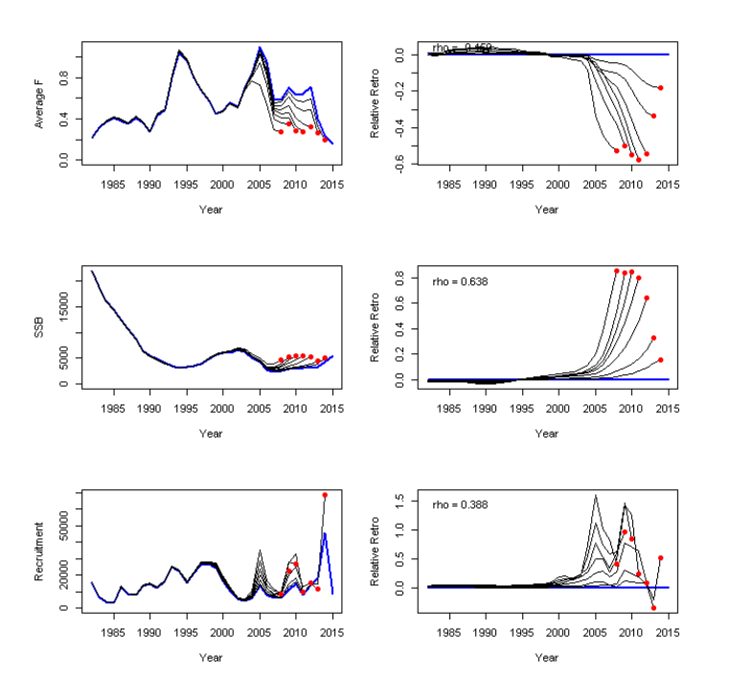
Figure 1. Retrospective patterns for Witch Flounder from proposed ASAP run in SARC 62.

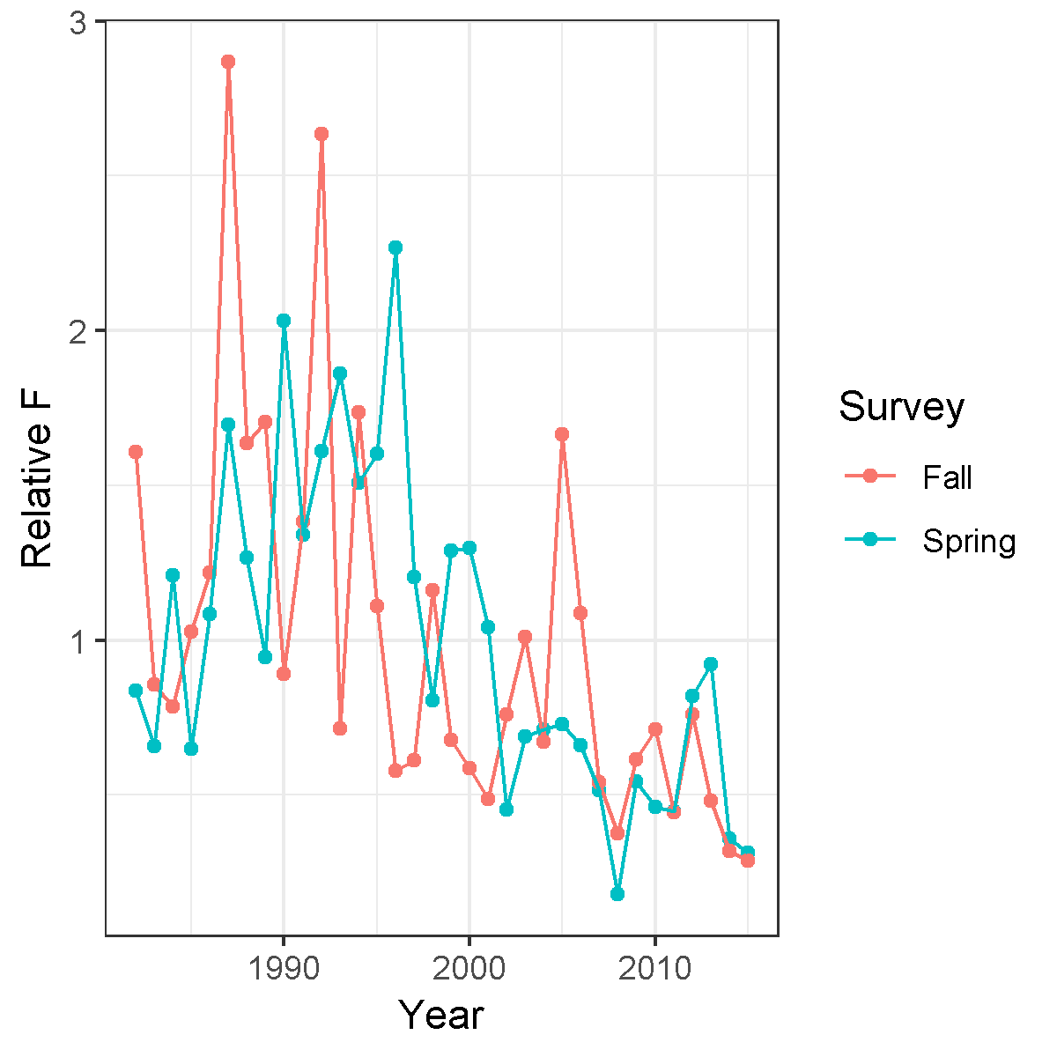
Figure 2. Relative F (rescaled catch/survey) for Witch Flounder from SARC 62.
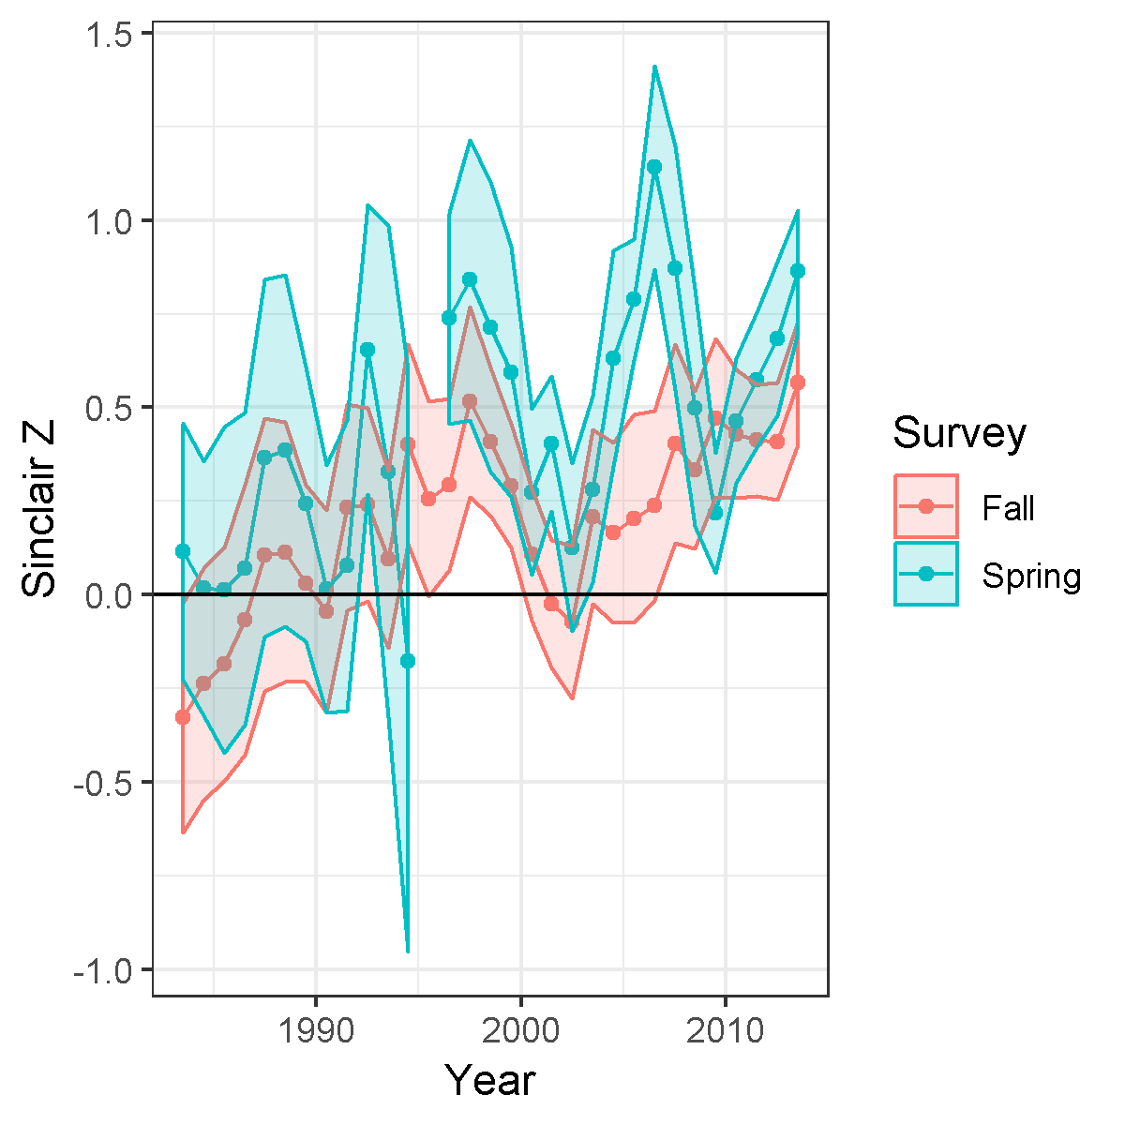
Figure 3. Total mortality from survey age composition (Sinclair Z) for Witch Flounder from SARC 62.
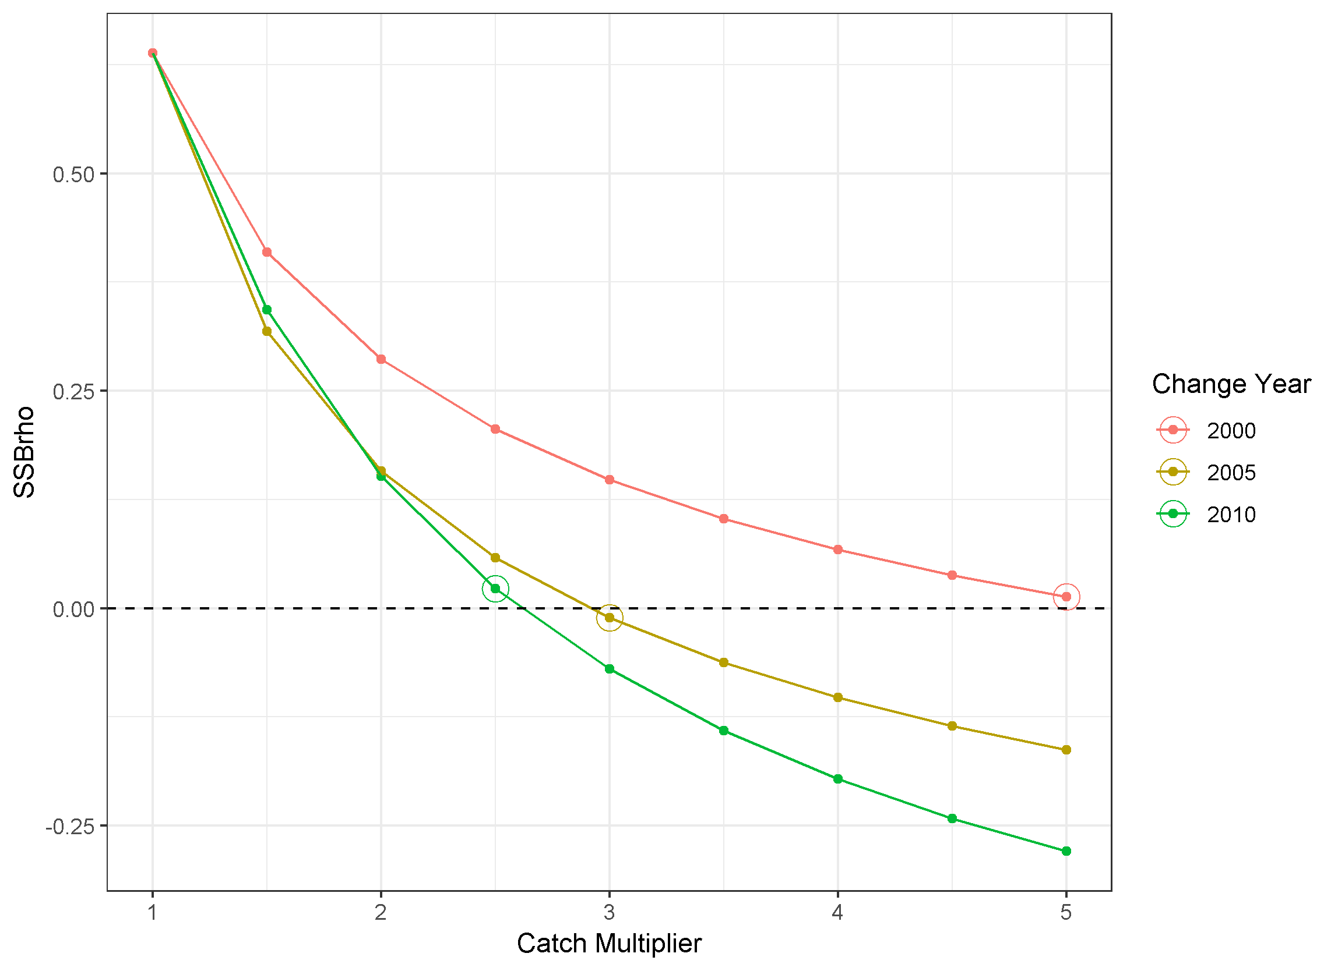
Figure 4. Mohn’s rho for spawning stock biomass (SSBrho) for Witch Flounder from SARC 62 under three change years and a range of catch multipliers applied across all ages.
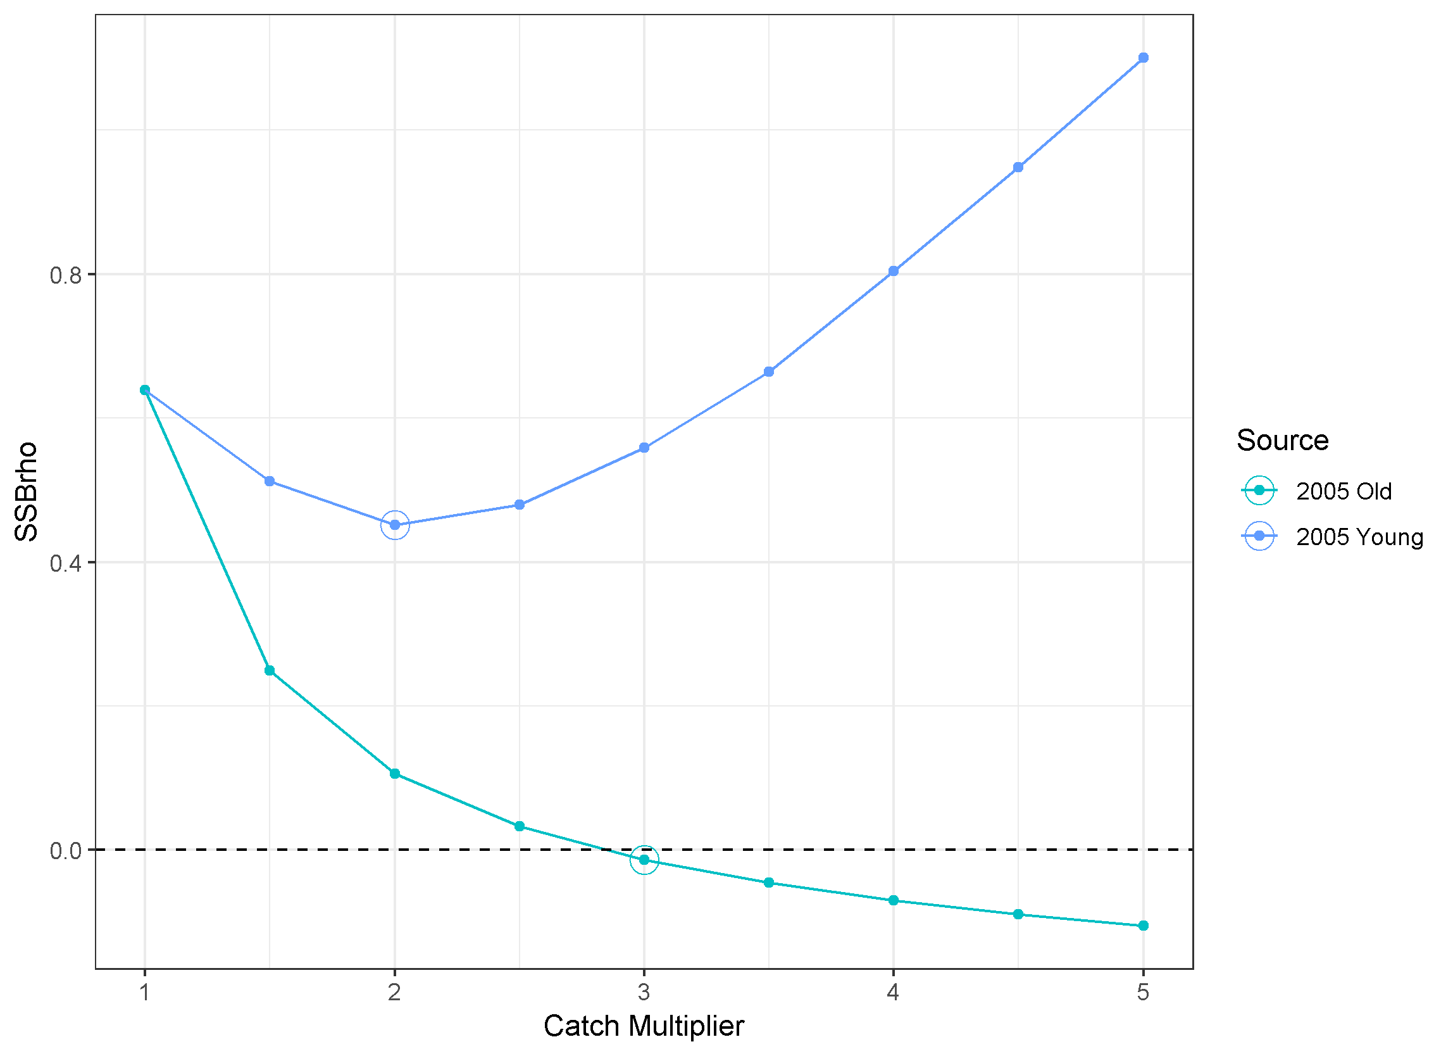
Figure 5. Mohn’s rho for spawning stock biomass (SSBrho) for Witch Flounder from SARC 62 under three change years and a range of catch multipliers applied across either young or old ages.
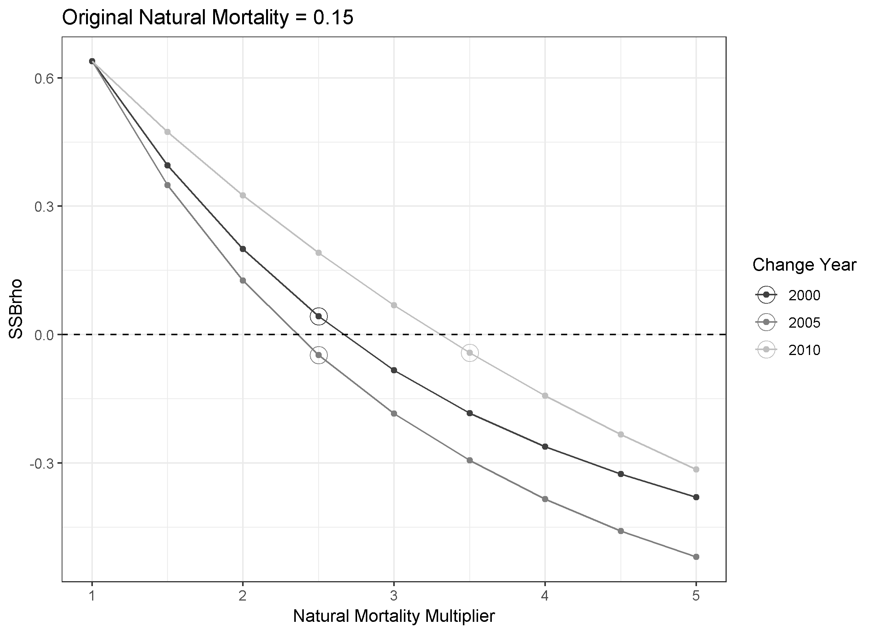
Figure 6. Mohn’s rho for spawning stock biomass (SSBrho) for Witch Flounder from SARC 62 under three change years and a range of natural mortality multipliers applied across all ages.
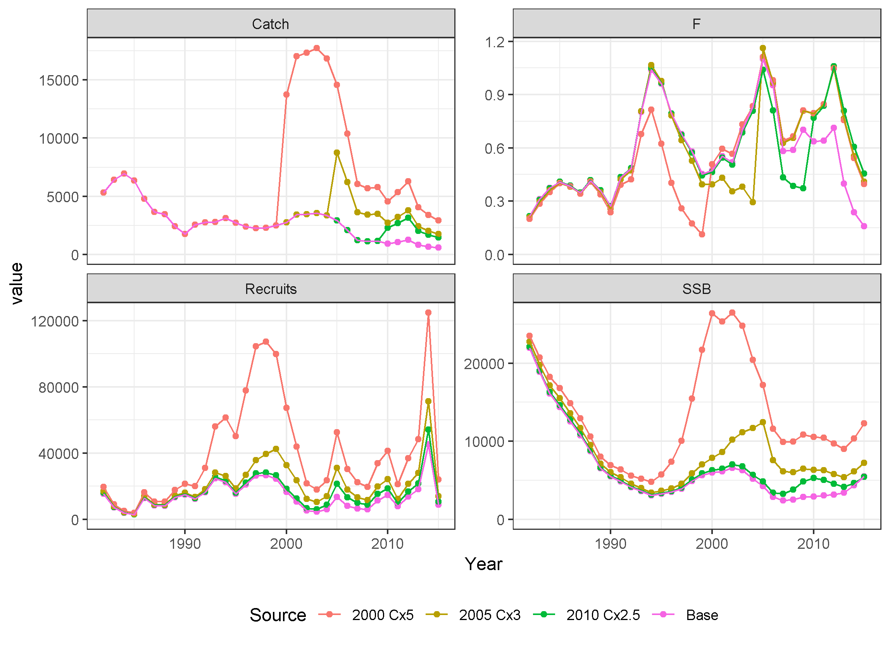
Figure 7. Catch, fishing mortality rate (F), recruits, and spawning stock biomass (SSB) time series for the base Witch Flounder assessment and three catch multipliers applied to all ages.
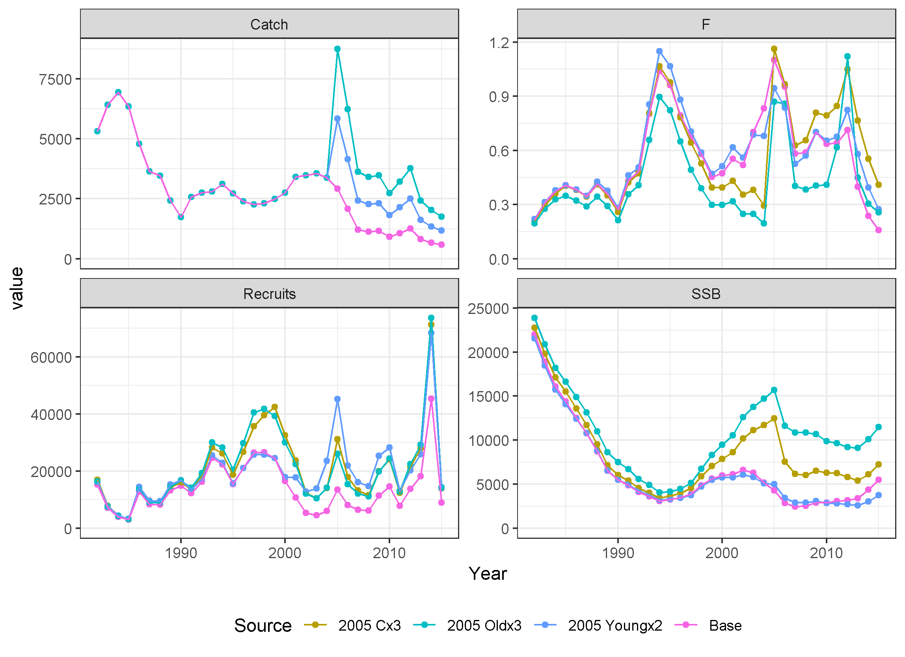
Figure 8. Catch, fishing mortality rate (F), recruits, and spawning stock biomass (SSB) time series for the base Witch Flounder assessment and catch multipliers applied to either young or old ages.
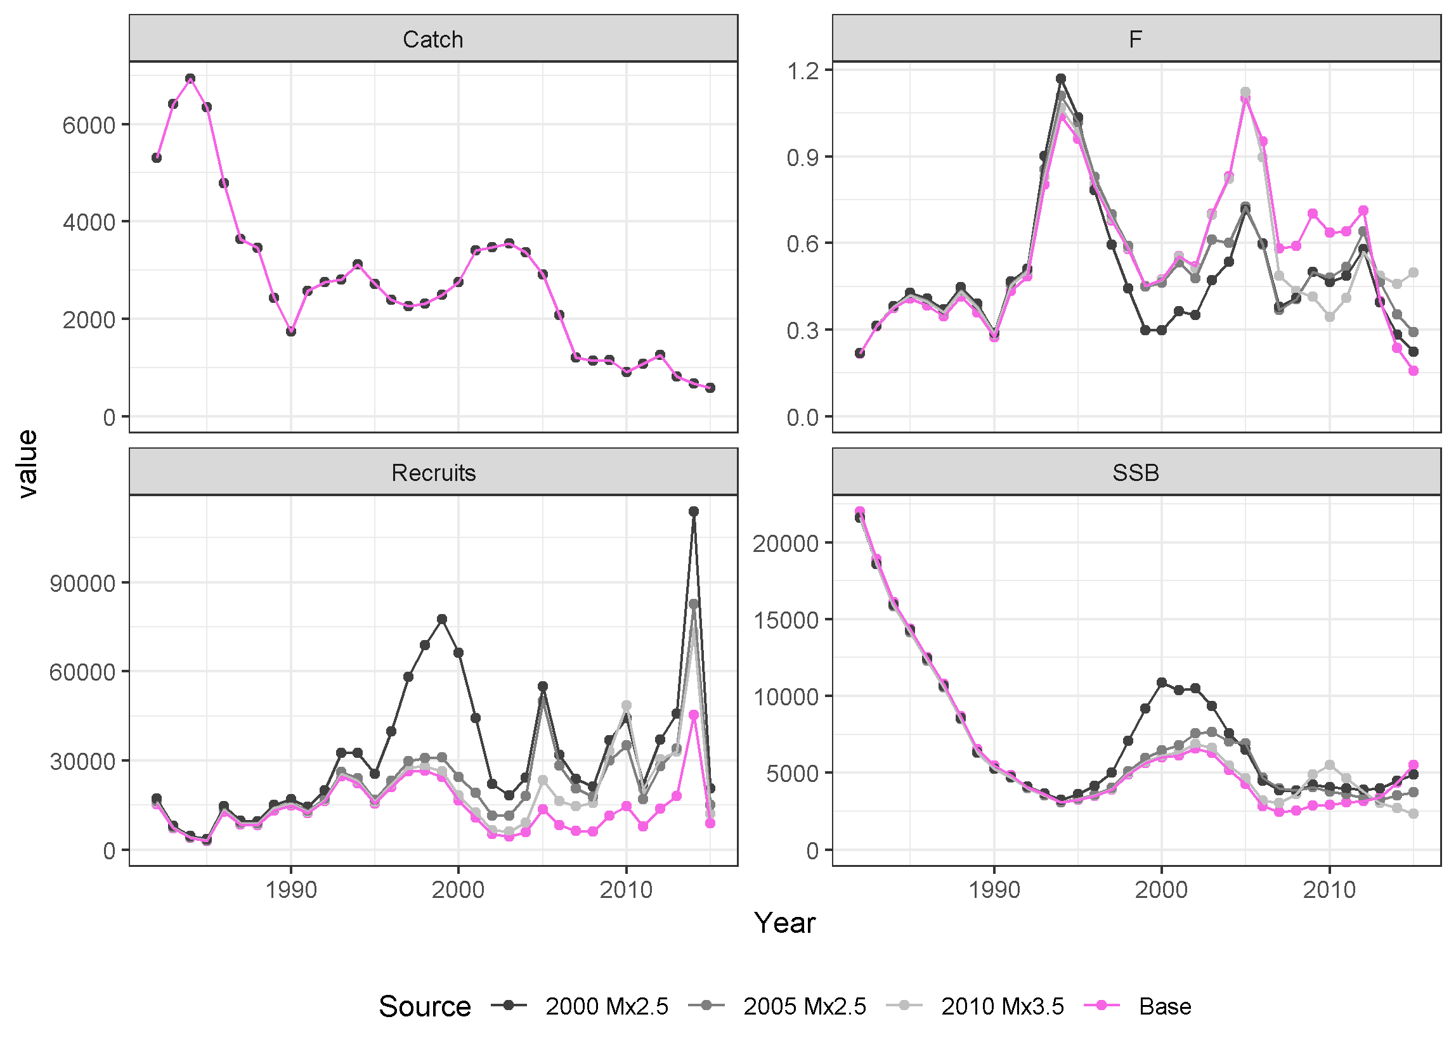
Figure 9. Catch, fishing mortality rate (F), recruits, and spawning stock biomass (SSB) time series for the base Witch Flounder assessment and three natural mortality multipliers applied to all ages.
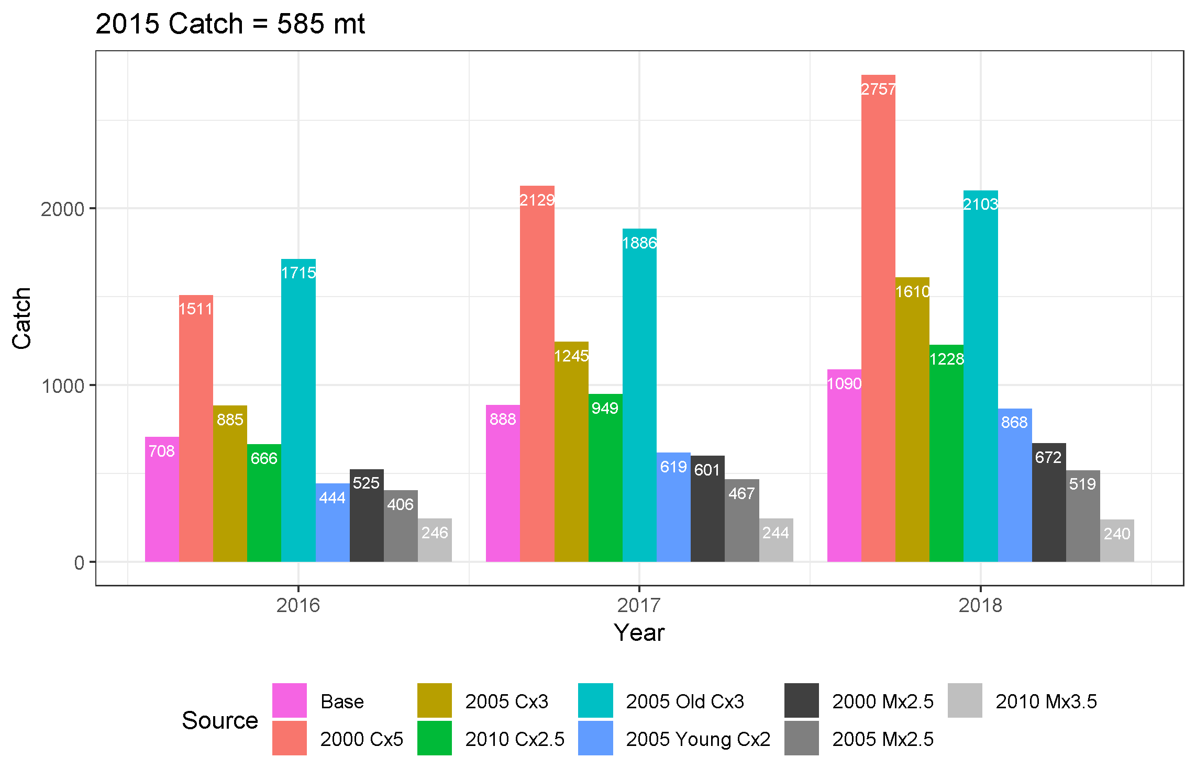
Figure 10. Catch advice (mt) for Witch Flounder under F40% for years 2016–2018 under a number of scenarios.
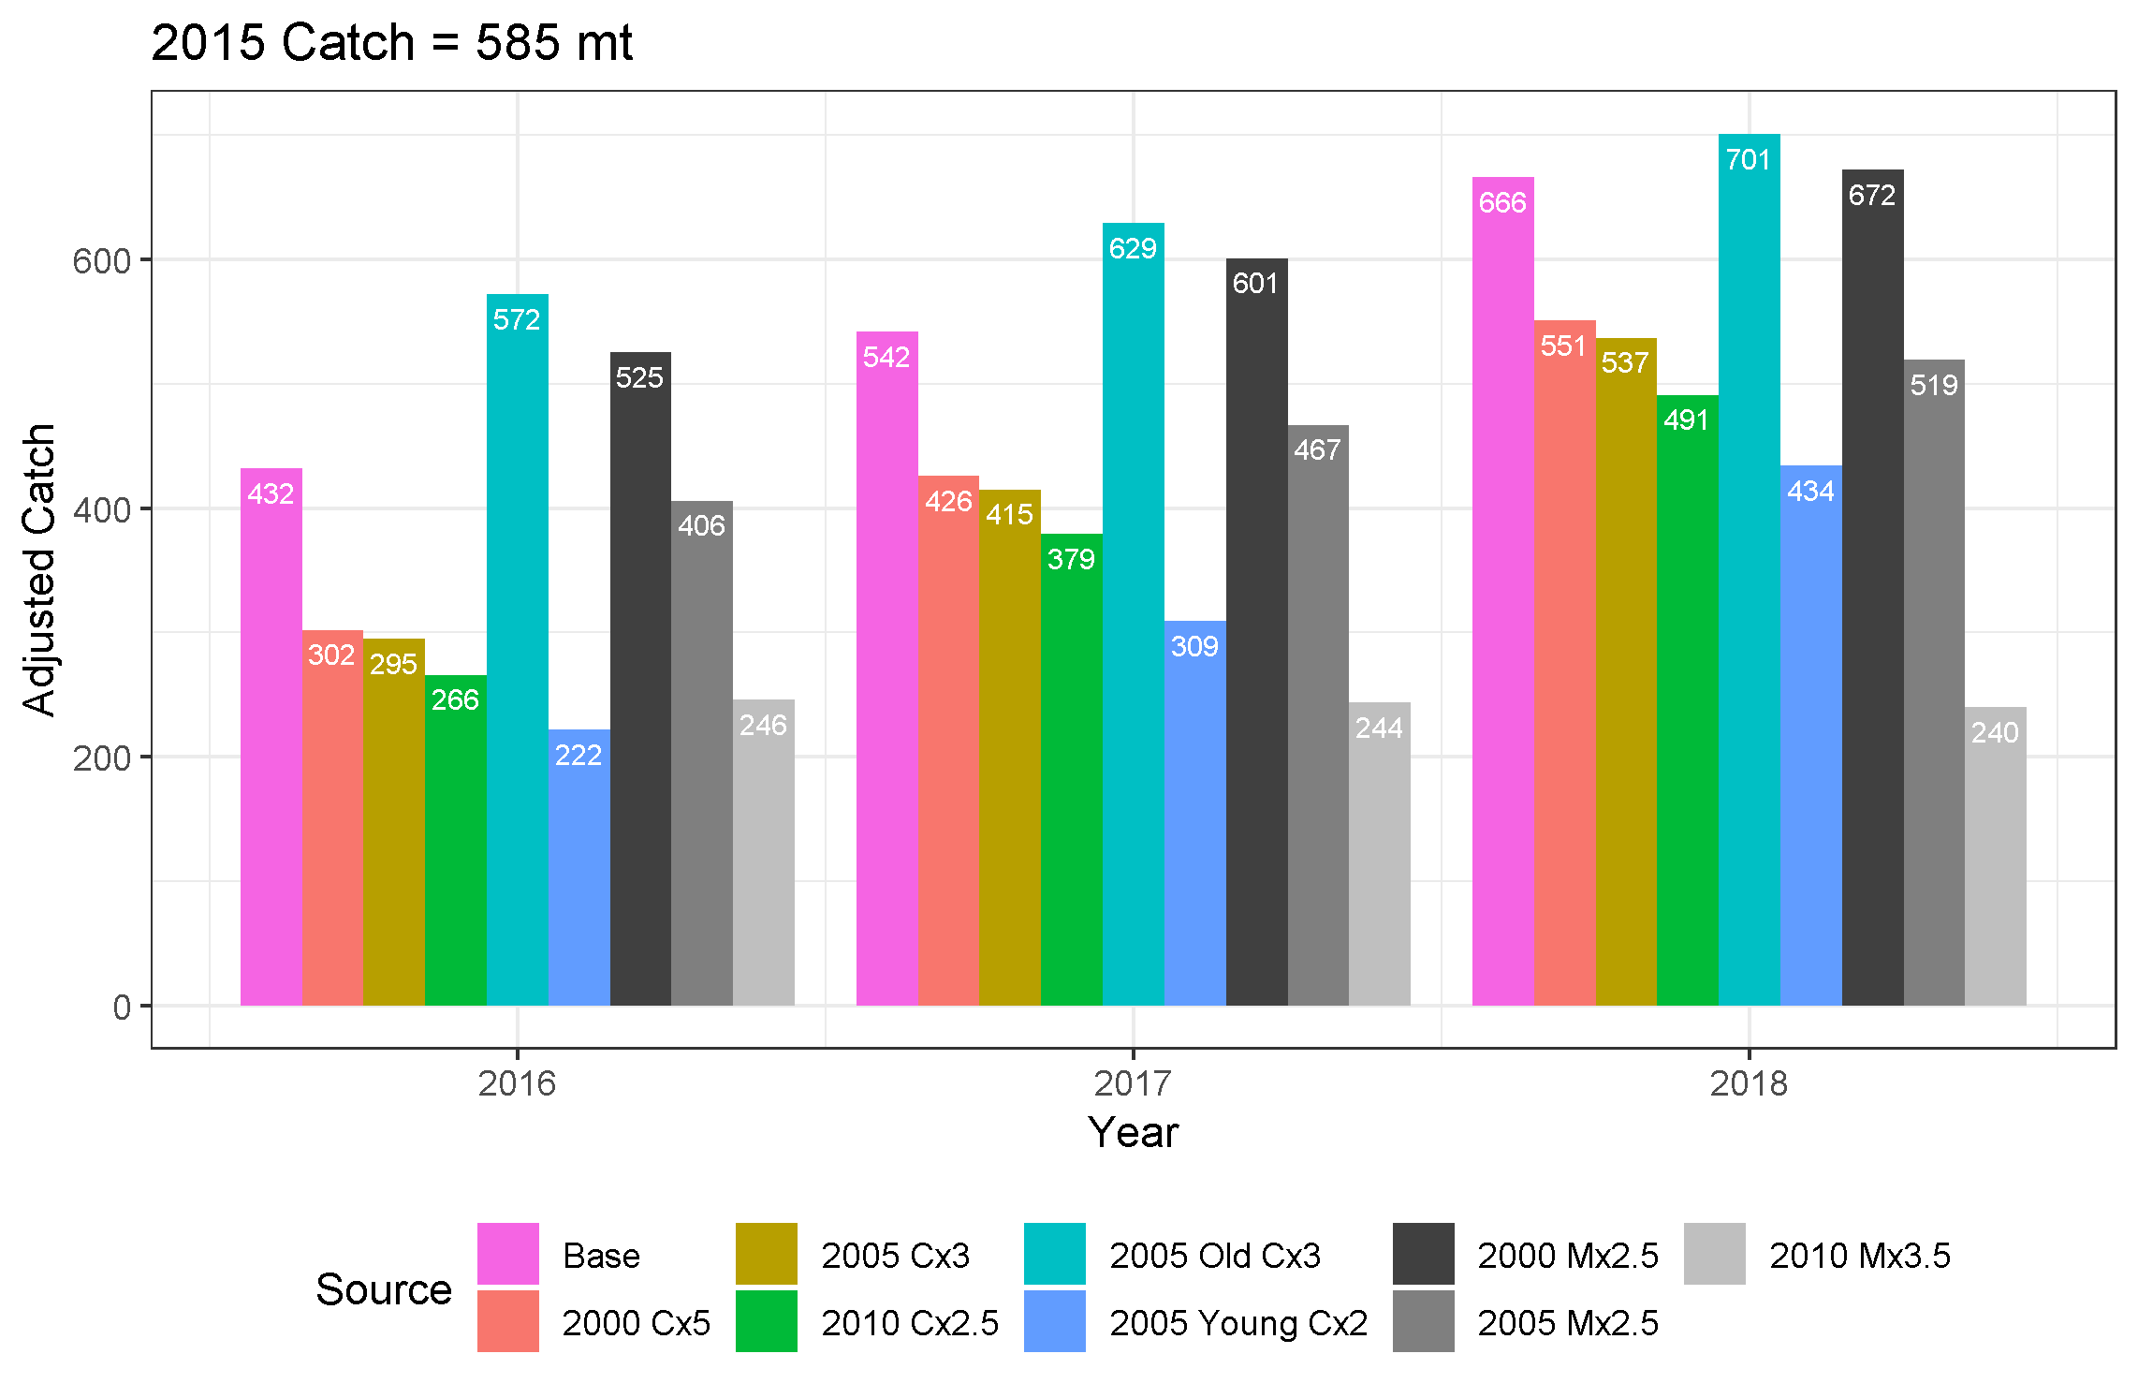
Figure 11. Adjusted catch advice (mt) for Witch Flounder under F40% for years 2016–2018 under a number of scenarios.
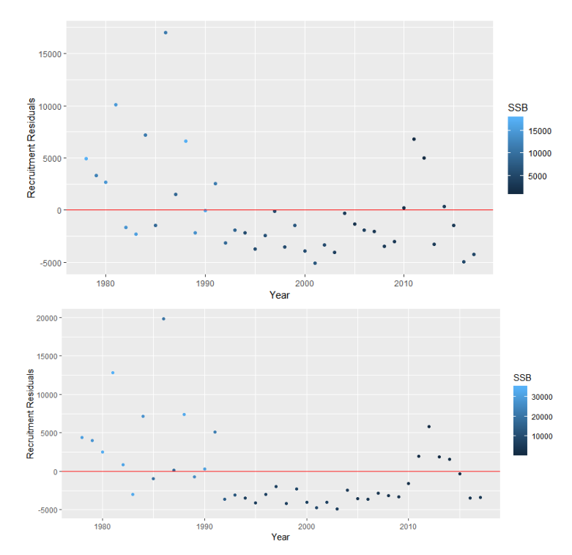
Figure 12. Recruitment residuals from Beverton-Holt Stock-Recruitment relationships fit to 2018 VPA (top panel) and ASAP (bottom panel) outputs.
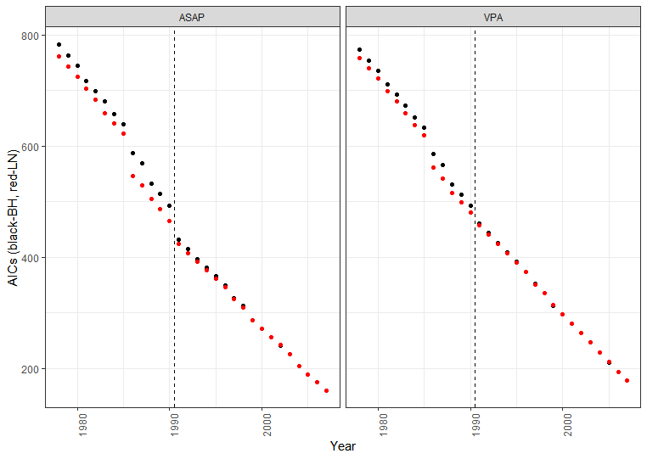
Figure 13. Akaike Information Criterion (AIC) values for Beverton-Holt (black) and Linear (red) relationship fits to the Stock-Recruitment data coming from the 2018 ASAP (left) and VPA (right) models.
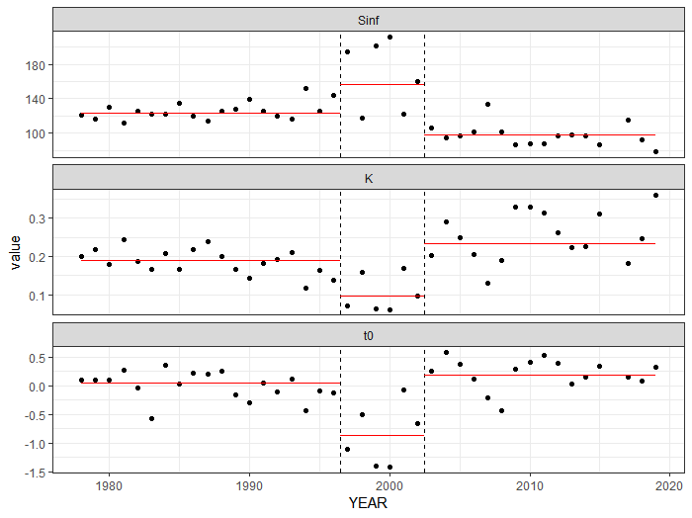
Figure 14. Temporal trends in VonBertallanfy growth parameters fit to survey data. Dashed vertical lines identify an approximate early (1978–1996), mid (1997–2002) and late (2003–2019) time period. Points are annual growth curve fits and red lines are growth curve fits spanning the whole time period.
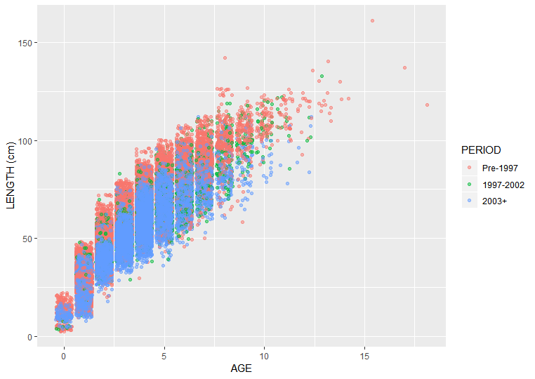
Figure 15. Length at age data from the three DFO and NMFS surveys since 1978, coloured by time period.
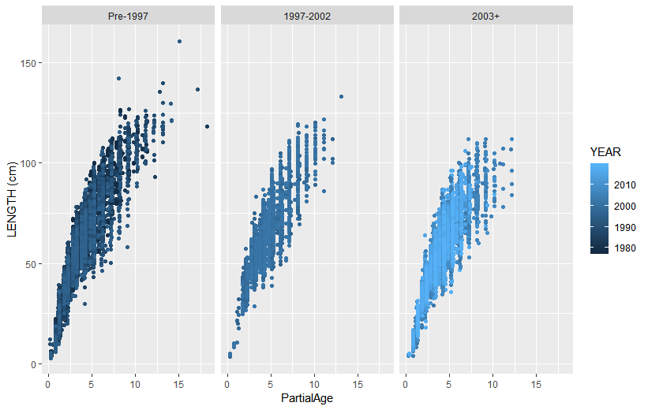
Figure 16. Available length at age data for all DFO and NMFS surveys since 1978. Facets represent the early (left), middle and late (right) time periods. Age has been adjusted to partial age to account for differences in survey timing.

