TRAC Working Paper 2013/08 (revised)

A Statistical Catch at Age Stock Assessment Model of
Eastern Georges Bank Atlantic Cod (Gadus morhua)

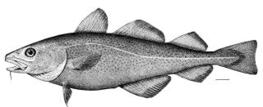

Loretta O’Brien
NOAA/National Marine Fisheries Service
Woods Hole Laboratory
Woods Hole, MA 02543

and

Yanjun Wang
Department of Fisheries and Oceans
St. Andrews Biological Station
St. Andrews, NB

TRAC
Benchmark Model Meeting
April 9-11, 2013

Introduction

The TRAC was established in 1998 to peer review assessments of transboundary resources in the Gulf of Maine-Georges Bank region to support management decisions of both the USA and Canada. Three species on Georges Bank were of interest at that time: cod, haddock, and yellowtail flounder. Prior to 1998 each country conducted assessments for these species, however, beyond exchanging the catch data required for each assessment, there was limited participation in the assessment preparation or subsequent peer review. For cod on Georges Bank, the USA conducted an assessment based on the unit stock of ‘Georges Bank cod’ defined as cod from NAFO Division 5Z and south (Figure 1), which includes USA statistical areas (SA) 521-522, 561-562, 551-552, 525- 526, and SA areas southward. In Canada, the assessment of cod was based on the management unit of ‘Eastern Georges Bank cod’ defined as cod from the eastern part of NAFO Division 5Ze that includes USA statistical areas 561-562 and 551-552, and Canadian SA 5j and m (Figure 2).

In 2000, the Transboundary Management Guidance Committee (TMGC) was established (http://www2.mar.dfo-mpo.gc.ca/science/tmgc/TMGC-e.html) for the management of transboundary stocks. In December 2001, the TMGC reached an agreement to recommend 5Zjm as the management unit for cod and haddock and 5Zhjmn for yellowtail flounder, with percentage catch share to each country based on contemporary resource distribution and historical landings (TMGC 2002). The USA, however, continued to assess and manage Georges Bank (GB) cod as a unit stock.

Since the establishment of TRAC and TMGC, the EGB cod assessment is reviewed within TRAC and quota allocation determined by the TMGC. The GB cod assessment, conducted by the USA, is reviewed in the Stock Assessment Workshop/Stock Assessment Review Committee (SAW/SARC) process and managed by the New England Fisheries Management Council. The GB cod assessment was reviewed for a brief time (1998, 2000, and 2001) within the TRAC but has subsequently been reviewed in the SAW/SARC process.

This working paper presents several model configurations of the statistical catch at age model ‘Age Structured Assessment Program’ (ASAP) as applied to the EGB cod data. The ASAP model was chosen to explore as an alternative to the virtual population model (VPA) because ASAP was recently accepted as the new benchmark model for the GB cod assessment, replacing the VPA that had historically been applied, since about 1978 (NEFSC 2013). Prior to 2004, both the EGB and GB cod assessments had been conducted with VPA and had similar formulations. After the 2002 EGB cod benchmark review (O’Boyle and Overholtz 2002) the assessments started to diverge. While it is not mandatory that the two assessment be similarly formulated, given that EGB cod data is in both assessments, it would be seem appropriate to have the populations on the same scale. Also, given that part or all of the Georges Bank cod stock is managed by both the TMGC and the NEFMC, respectively, similarly scaled populations would allow for compatibility in management decisions.
Assessment Model Formulation

ASAP

The Age Structured Assessment Program (ASAP) was used to derive estimates of instantaneous fishing mortality in 2011 and stock size in 2011. A retrospective analysis was performed for terminal year fishing mortality, spawning stock biomass, and age 1 recruitment.

Model description
ASAP, a forward projecting statistical catch at age model (Legault and Restrepo 1998) can be downloaded from the NOAA Fisheries Toolbox (NFT, http://nft.nefsc.noaa.gov/). As described at the NFT software website, ASAP is an age-structured model that uses forward computations assuming separability of fishing mortality into year and age components to estimate population sizes given observed catches, catch-at-age, and indices of abundance. Discards can be treated explicitly. The separability assumption is partially relaxed by allowing for fleet-specific computations and by allowing the selectivity at age to change in blocks of years. Weights are input for different components of the objective function which allows for configurations ranging from relatively simple age-structured production models to fully parameterized statistical catch at age models.

The objective function is the sum of the negative log-likelihood of the fit to various model components. Catch at age composition is modeled assuming a multinomial distribution. Surveys can be treated as either “West Coast style” in the same manner as the catch data with a total survey time series and survey catch at age composition modeled assuming a multinomial distribution, or “East Coast style” with the survey indices at age entered as separate series. Most other model components are assumed to have lognormal error. Specifically, lognormal error is assumed for: total catch in weight by fleet, survey indices, stock recruit relationship, and annual deviations in fishing mortality. Recruitment deviations are also assumed to follow a lognormal distribution, with annual deviations estimated as a bounded vector to force them to sum to zero (this centers the predictions on the expected stock recruit relationship). For more technical details, the reader is referred to the technical manual (Legault 2008).

Data input

Input to the ASAP model includes the total catch (mt) for the combined landings and discards of USA and Canadian fleets (Tables 1a-1b, Figure 3), and the catch-at-age (Table 2, Figure 4) and weight-at-age (Table 3, Figure 5) for ages 1-10+ during 1978-2011. Beginning year weight-at-age is back-calculated from the mid-year catch weight-at-age (Table 4, Figure 6) and also estimated from an average of the DFO and NEFSC spring research survey weight-at-age (Table 5, Figure 7). Swept-area population estimates derived from indices of abundance include the Canadian DFO 1986-2011 estimates for ages 1- 10+ (Table 6, Figure 8), the NEFSC 1978-2011 standardized spring estimates for ages 1- 10+ (Table 7, Figure 9a-9b), and the NEFSC 1978-2011 standardized autumn estimates for ages 1-6 (Table 8,Figure 10). The NEFSC spring survey was dis-aggregated into two series based on the use of the Yankee #41 otter trawl from 1978-1981 and the Yankee #36 otter trawl after that time. Maturity was age and time invariant and was assumed knife edge maturity at age 3 as in previous EGB cod assessments. Natural mortality was age and time invariant and was assumed to be 0.2 as in previous assessments (Wang and O’Brien 2012).

Model formulations

Run1_o3.1
The first ASAP model run (run1_o3.1) was run based closely on the formulation of the recent peer-reviewed benchmark model of GB cod (NEFSC 2013). A multinomial distribution was assumed for both fishery catch at age and survey age compositions. The survey time series were not split between 1994/1995 as had been done in previous EGB cod VPA formulations (Wang and O’Brien 2012). The catch CV was initially set equal to 0.05 and the recruitment CV set equal to 0.5, however, the recruitment deviations were set with lambda = 0, so the deviations did not contribute to the objective function. The CV for each survey was initially set at the value generated from the Department of Fisheries and Oceans (DFO) STRANAL (Stratified Analysis) software package.

Both the fishery and survey selectivity was modeled as ‘flat-topped’. For the fisheries, two selectivity blocks were modeled as single logistic from 1978-1993 and 1994-2011, although initially four blocks had been considered. The determination for these choices is described below, which is excerpted from the GB cod assessment report (NEFSC 2013):

Model estimates of selectivity at age were initially freely estimated for the surveys and the fisheries with no restriction for flat-topped or dome-shaped results. Starting with the survey
selectivity, the catchability (q) for each age was initially set based on values estimated by the VPA-like ASAP. Age 7 was fixed at 1 in the DFO survey, age 6 was fixed at age 1 in the NEFSC autumn, and age 8 was fixed at 1 in the NEFSC spring survey. The results of the fit indicated that the survey catchability was essentially ‘flat-topped’. The CVs associated with each estimate at age were high for ages 9 and 10+ in both the DFO and NEFSC spring survey, indicating a poor fit. The CVs for all other ages were .25 or less for all three surveys. In each survey, selectivity was estimated at 1 for other ages in addition to the age that had been fixed at 1, i.e. ages 5 and 6 in DFO, age 4 in NEFSC autumn, and age 5 and 6 in the NEFSC spring. Given these results the NEFSC spring and DFO survey selectivities were fit using a single logistic. For the autumn survey, further comparison of selectivity at age vs. logistic fit indicated better diagnostics with selectivity for age 3 fixed at 1 (Figure 11-this document).

For the fishery selectivity, when selectivity was freely estimated for both the survey and the fishery, each of the four fishery blocks appeared to have a moderate dome. Selectivity was fixed at age 1 for ages 3, 4, 5, and 5 in blocks 1978-1982, 1983-1993, 1994-1999, and 2000-2011. Examination of the fit statistics for the older ages indicated high CVs for ages 9 and 10+ (0.78-2.92) in all blocks and for age 8 (CV=0.79) in the 1978-1982 block. These results indicated that a flat-topped selectivity was more appropriate. When the survey selectivities were fit with a logistic and the fishery selectivity blocks were freely estimated, the fishery indicated flat-topped selectivity in the 3rd block (1994-1999) and a weak dome in the other 3 blocks, again with high CVs for the older ages. In each of the blocks selectivity was estimated at 1 for at least one age. Given these results, a logistic was fit to all 4 fishery blocks. Examination of the logistic fit of the four blocks clearly indicates only 2 blocks are appropriate given the similarities between blocks 1 and 2 (1978-1982, 1983-1993) and blocks 3 and 4 (1994-1999, and 2000-2011) (Figure 12- this document). A model with two fishery blocks (objective function (OF) = 2713, 91 parameters) is more parsimonious than a 4 block model (OF=2712, 95 parameters) with only 1 point increase in the OF with 4 less parameters

The diagnostics of the logistic fit of the EGB fishery selectivity blocks in run1_o3.1 (Figure 13) indicated low CVs for both blocks for all four parameters:

The effective samples size (ESS) of the catch and surveys were adjusted based on interpretation of the ‘Francis’ plots that compare the observed mean age with the model predicted estimates (Francis 2011). The ESS estimated for the catch at age data (treated as multinomial) was compared to the input effective sample size and was adjusted iteratively until the ESS specified generally matched the mean model estimated value. The final ESS was set at 32 based on the stage 2 multiplier as described by Francis (2011). The CV for total catch was initially set at
0.05 but preliminary runs indicated retrospective diagnostics with two years that had a divergent solution. Increasing the catch CV=0.1 resulted in a stable solution.

The CV for each survey was initially set at the value generated from the survey estimate of stratified mean number per tow (DFO STRANAL). For the DFO survey the CVs averaged 0.31, with a range of 0.15-0.66, for the NEFSC spring the CVs averaged 0.32, with a range of 0.13-0.83, and for the NEFSC autumn survey the CVs averaged 0.47, with a range of 0.24-0.88. Further examination of the model fits to the survey indices resulted in adding the following constant to each survey CV vector: 0.25 (DFO), 0.3 (NEFSC spring #36), and 0.2 (NEFSC autumn), except the NEFSC spring #4, which was not adjusted. The input ESS for the survey catch at age was manually adjusted until the model estimate was close to the input value. The final ESS was based on the stage 2 multiplier as described by Francis (2011) and was set for each of the surveys as: DFO = 15, NEFSC autumn = 10, NEFSC spring 41=15 and NEFSC spring 36 =22.

Run1_o3.1_sv
This run has the same input and formulation as run1_o3.1, except that the beginning year catch weight-at-age matrix is replaced with the survey averaged (DFO, NEFSC spring) weight-at-age matrix.

Run3d
This run has the same inupt and formulation as run1_o3.1, with two exceptions. The catch CV was set at 0.05 instead of 0.1, and instead of adjusting the ESS of catch and survey based on the Francis (2011) method, the ESS were adjusted based on the so-called ‘Ianelli’ plots (McAllister and Ianelli 1997). The input ESS is compared to the model predicted ESS and an appropriate ESS is considered to be that which more or less intersects the input ESS. This formulation was in response to the low ESS for the surveys in run1o_3.1. The relatively small ESS for the autumn and DFO surveys gives these surveys minimal influence in the model results.

The catch ESS was initially set at 100 and the ESS for each survey set at 50.

Run3f

This run has the same formulation as run3d, except that the catch ESS is split set at 75 for 1978-1995 and 125 for 1996-2011, and the survey ESS remains at 50.

Model Results

Model results, including the objective function (OF), number of parameters, components to the OF, the root mean square error (RMSE), computed from standardized residuals, and the 2011 SSB and F estimates are summarized for all runs in Table 9. Specific results of several runs are described below.

Run1_o3.1 results
Catch
As a result of the slight increase in CV from 0.05 to 0.1 assigned to the commercial catch the model fit to the observed catch is not fit as closely in the late 1980s and early 1990s as in the other years (Figure 14). The catch age composition exhibits higher residuals in the early time period, with a pattern of negative residuals for age 3 (Figure 15). The magnitude of the input ESS are appropriate given that the predicted mean age of the catch is generally within the 95% confidence interval (CI) of the observed mean ages (Figure 16) and the RMSE (0.92) is close to 1.0 (Francis 2011).

Indices
The fit of the predicted indices through the observed DFO survey indices was better during the period 1995-2000 than before or after that period (Figure 17). A pattern of negative residuals in the older age groups during 1986-1995 and in the younger ages during 2000-2011 is apparent in the age composition (Figure 18). The final DFO survey ESS was set at 15, with a RMSE = 0.98 and the predicted mean age fitting well in the middle of the time series but above the observed mean age earlier in the time series (Figure 19).

The fit of the predicted indices through the NEFSC autumn survey indices did not show any strong patterning (Figure 20). The maximum residual of the age composition is the largest of the 4 surveys (Figure 21). The age 1 residuals are large and have a positive values in the early years and a negative pattern in the later years , however the older ages do not exhibit this pattern (Figure 21). The final input ESS was set at 10, with a RMSE 1.37 (Figure 22). This is the lowest ESS of all the surveys and the predicted mean age does not fit the observed mean age as closely at the beginning of the time series compared to the later years (Figure 22).

The model fit diagnostics for the NEFSC spring (Yankee #41) are presented in Figures 23-25. With only 4 years of survey indices, no patterns are easily described or evaluated.

The fit of the predicted indices through the NEFSC spring (Yankee #36) survey indices indicated, similar to the DFO survey, a series of negative residuals in the late 1980s to 1994 and a series of positive residuals in the mid-2000s (Figure 26). The residuals of the age composition show a pattern of positive residuals in age 2 and negative in age 4 in the early years and the opposite in the later years (Figure 27). The input ESS was set at 22, with an RMSE of 0.98. The predicted mean age fit through almost all the observed mean age confidence intervals (Figure 28).

Fishing mortality, SSB, and recruitment
Fully recruited F (unweighted, ages 5+) was estimated at 0.19 in 2011 (Table 10, Figure 29), a 36% decrease from 2010. SSB in 2011 was estimated at 6,293 mt, a 7% increase from 2010 (Table 10, Figures 29-30). Recruitment (millions of age 1 fish) of the 2003 year class (3 million) is now estimated to be smaller than the 1998 year class (3.5 million), and the 2010 year class is estimated to be 5.2 million, the largest since the 1990 year class (Table 10, Figures 29-30).

Retrospective analysis
A retrospective analysis was performed to evaluate how well ASAP calibration would have estimated F, SSB, and recruits at age 1 for seven years (2004-2010) prior to the terminal year, 2011. The pattern of over estimating SSB and underestimating F relative to the terminal year as observed in the VPA (Wang and O’Brien 2012) continues in this model (Figure 31). The retrospective rho values, the average of the last 7 years of the relative retrospective peels, were 0.723 for SSB, -0.488 for F_{5+ ,} and -0.265 for recruitment. Applying a retrospective adjustment ((1/1+rho) * estimate) results in 2011 estimates of F=0.37, SSB=3,633 mt, age 1 recruitment =7.1 million fish.

Run1_o3.1_sv results

Model diagnostics and results are the same as run1_o3 (Table 9), except for results related to biomass, given that the beginning year weight-at-age is based on survey data rather than catch data.

Beginning year biomass in 2011 was 15% lower than that in run1_o3.1, and SSB was
9% lower than that in run1_o3.1.

Run3d.1 results

Model results are presented in Table 9. Examination of the diagnostic plots of observed vs model predicted ESS for catch indicated that the value of 100 was perhaps not sufficient to characterize the difference before and after the mid-1990s (Figure 32). The ESS appears too high from 1978-1995 and too low from 1996-2011. The ESS was modified and detailed results are described for run3f.1.

SSB is lower than in run1 and F is higher (Table 9), however, the retrospective bias is reduced in this run and ranges between -0.25-0.25 and there is little retrospective pattern.

Run3f.1 results

Catch
The model fit to the observed catch is almost exact with the CV of 0.05 assigned to the commercial catch (Figure 33). The catch age composition exhibits larger residuals in the early time period, with a pattern of negative residuals for age 3 (Figure 34). The magnitude of the input ESS appears appropriate given that the predicted ESS generally bisects the observed ESS (Figure 35).

Indices
The fit of the predicted indices through the observed DFO survey indices was better during the period 1995-2000 than before or after that period (Figure 36). A pattern of negative residuals in the older age groups during 1986-1995 and in the younger ages during 2000-2011 is apparent in the age composition (Figure 37). The final DFO survey ESS was set at 50 and appears appropriate given that the predicted ESS generally bisects the observed ESS (Figure 38).

The fit of the predicted indices through the NEFSC autumn survey indices did not show any strong patterning, although in recent years the model fit does not bisect the survey confidence bounds for 3 years (Figure 39). The maximum residual of the age composition is the largest of the 4 surveys at 0.36. The age 1 residuals are large and have a positive values in the early years and a negative pattern in the later years , however the older ages do not exhibit this pattern (Figure 40). The final input ESS was set = 50 and appears appropriate given that the predicted ESS generally bisects the observed ESS (Figure 41).

The model fit diagnostics for the NEFSC spring (Yankee #41) are presented in Figures 42-44. With only 4 years of survey indices, no patterns are easily described or evaluated.

The fit of the predicted indices through the NEFSC spring (Yankee #36) survey indices indicated, similar to the DFO survey, a series of negative residuals in the late 1980s to 1994 and a series of positive residuals since the mid-2000s (Figure 45). The residuals of the age composition show a pattern of positive residuals in age 2 and negative in age 4 in the early years and the opposite in the later years (Figure 46). The input ESS was set =50 and appears appropriate given that the predicted ESS generally bisects the observed ESS (Figure 47).

Fishing mortality, SSB, and recruitment
Fully recruited F (unweighted, ages 5+) was estimated at 0.45 in 2011 (Table 11, Figure 48), a 48% decrease from 2010. SSB in 2011 was estimated at 3002 mt, a 9% decrease from 2010 (Table 11, Figures 48-49). Recruitment (millions of age 1 fish) of the 2003 year class (2.7 million) is now estimated to be smaller than the 1998 year class (3.4 million ) and the 2010 year class is estimated at 2.4 million (Table 11, Figures 48-49).

Retrospective analysis
A retrospective analysis was performed to evaluate how well ASAP calibration would have estimated F, SSB, and recruits at age 1 for seven years (2004-2010) prior to the terminal year, 2011. The pattern of over estimating SSB and underestimating F relative to the terminal year as observed in the VPA (Wang and O’Brien 2012) is not very strong in this model for F and SSB, but there is a pattern of underestimating recruitment relative to the terminal year estimate (Figure 50). The retrospective rho values, the average of the last 7 years of the relative retrospective peels, were 0.025 for SSB, -0.054 for F_{5+ ,} and -0.529 for recruitment. Applying a retrospective adjustment ((1/(1+rho)) * estimate) results in 2011 estimates of F=0.48, SSB=2,930 mt, age 1 recruitment =5.1 million fish.

Model uncertainty - MCMC

A Monte Carlo Markov chain (MCMC) simulation was performed to estimate uncertainty in the model estimates. The MCMC provides posterior probability distributions of the SSB and average F₅₊ time series. Two MCMC chains of initial length of 5.0 million were simulated with every 2,500th value saved. The trace of each chain’s saved draws suggests good mixing for both SSB (Figure 51) and F (Figure 52). The lagged autocorrelations showed decreased correlation with increased lag with correlations ≤ 0.1 beyond lag 1 for SSB and F (Figure 53). From the MCMC distributions, a 90% probability interval (PI) was calculated to provide a measure of uncertainty for the model point estimates for SSB and average F₅₊. Time series plots of the 90% PIs as well as plots of the posterior probability distributions for SSB₂₀₁₁ and average F₅₊ are shown in Figures 54-56.

The 2011 SSB estimate of 3,002 mt has a 90% PI of 2,093 mt – 4,307 mt and the 2011 average F₅₊ = 0.45 has a 90% PI of 0.30- 0.69.

Envelope Analysis
An ‘envelope analysis’ is presented as a simple method to bound reasonable abundance estimates. Based on Baranov’s catch equation, with swept area estimates of biomass from the NEFSC spring, NEFSC autumn, and DFO surveys, plausible assumptions are made on upper and lower bounds of catchability (q) and F to estimate population biomass for each survey. Specific details can be found in TRAC WP 2013/9 (this meeting). The upper and lower bounds of biomass from each of the surveys and the catch from the analysis indicate that the ASAP model run3f.1 results are generally within the bounds and thus is not an unreasonable estimate of biomass (Figure 57).

Biological Reference Points

Yield per Recruit Analysis
A yield per recruit (YPR) analysis was conducted using the methods of Thompson and Bell (1934). Input data for catch and stock weights (ages 1-10+) were derived from an average of the most recent five years (2007-2011). The partial recruitment (PR) was based on a normalized arithmetic mean of 2007-2011 total fishing mortality from the ASAP model run3f.1. The maturity ogive is knife-edge at age 3. Results of YPR analysis are presented below, in Table 12 and Figures 58-59. The current negotiated EGB cod F reference point is F_{ref} =0.18 (TMGC meeting December 2002). (The current GB cod F_{MSY} proxy= F_{40%} = 0.18).

EGB cod is not managed by biomass reference points, however, for background purposes, non-parametric estimates of MSY and SSB_{MSY} based on F_{40%} were estimated using the 34-year time series mean recruitment (5.484 million age 1 fish), Y/R (1.22) and SSB/R (7.18) as: F_{40%} = 0.19, MSY = 6,677 mt , SSBmsy = 39,353 mt (Table 13).

MSY Biological Reference Points
Long-term Stochastic Projection
Long term (100 years) stochastic projections were run using the same input data as the YPR with F_{REF} = 0.18. Following the GB cod accepted assessment projection formulation (NEFSC 2013), recruitment was estimated from a 2 stage cumulative distribution function (CDF) based on either 19 low estimates or 14 high estimates of age 1 recruitment. Based on a visual examination of the stock recruit plot (Figure 49), when SSB is < 15,000 mt recruitment is drawn from the low recruitment CDF, and when SSB >15,000 mt then recruitment is drawn from the high recruitment CDF.

The long term projection provided the following non-parametric biomass reference points:
F_{REF} = 0.18,
MSY = 11,059 mt (80% CI: 2,065 mt - 14,180 mt),
SSB_{MSY} = 30,622 mt (80% CI: 25,450 mt - 84,346 mt).

Projections
Short term stochastic projections under F_{40%} were performed from the run 3f.1 model results to estimate landings and SSB during 2013-2015. The input values for mean catch and stock weights, PR, and maturity are the same as described above for the YPR analysis. Recruitment was estimated from the 2-stage CDF described above and associated with a SSB breakpoint of 15,000 mt. Catch in 2012 was estimated based on assumption that the 2012 quota would be caught.

The results of the short term projections (Table 14) indicate under an F_{40%} = 0.19 catch is projected to increase each year through 2015, and SSB is also projected to increase in each year through 2015 (Table 14).

Summary Discussion
Productivity of EGB has been low for the last two decades with poor recruitment and truncated age structure. An increase in natural mortality may have contributed to the recent low productivity, however, food habits data do not support this hypothesis (NEFSC 2013b). Analysis of tagging data indicates minimal increase in M from the 1980s to the 2000s, and thus does not appear sufficient to explain the long term low productivity (Miller WP 2). Lack of large numbers of older repeat spawners in the EGB cod population since the mid-1980s may contribute to the long-term low productivity. Cod have a low success rate of hatching for 1st and 2nd time spawners (13% and 62%) until the 3rd spawning (100%), suggesting that an expanded age structure of fish that have spawned 3 or more times would contribute to higher productivity (Trippel 1998). Long-term overfishing may have also had indirect effects. Fishing activity disrupts the spawning aggregation and thus behaviors and rituals of cod, reducing the potential of good recruitment (Dean 2012). Spawning of cod involves complex behaviors that have only recently been observed including arrival and departure of fish on the spawning ground at different times dependent upon sex, age, and stage of maturity (Lawson and Rose 2000) and the formation of spawning leks, where the males set up and defend territory (Windle and Rose 2007).
Based on model diagnostics and the lack of strong retrospective bias, run3f.1 is put forth as the preferred model. This model formulation exhibits minimal retrospective bias in F and SSB that had been prevalent in previous assessments, however, additional variability was added to the survey abundance estimates, thus placing more emphasis on the catch data.

Literature Cited

Dean, M. J., W.S. Hoffman, and M. P. Armstrong. 2012. Disruption of an Atlantic Cod
Spawning Aggregation Resulting from the Opening of a Directed Gill-Net Fishery. No.Am.J.
Fish. Manage. 32:124-134.

Francis R.I.C.C. 2011. Data weighting in statistical fisheries stock assessment models. Can. J. Fish. Aquat. Sci. 68:1124-1138.

Lawson, G. L. and G. A. Rose. 2000. Small-scale spatial and temporal patterns in spwaning of
Atlantic cod (gadus morhua in coastal Newfoundland waters. Can. J. FIsh. Aquat. Sci. 57:1011-
1024.

Legault C.M. 2008. Technical Documentation for ASAP Version 2.0 NOAA Fisheries Toolbox (http://nft.nefsc.noaa.gov/).

Legault, C.M. and V.R. Restrepo. 1998. A flexible forward age-structured assessment program. ICCAT. Col. Vol. Sci. Pap. 49:246-253.

McAllister, M. K. and J. N. Ianelli. 1997. Bayesian stock assessment using catch-age data and
the sampling-importance resampling algorithm. Can. J. FIsh. Aquat. Sci. 54:284-300.

NEFSC. 2013a. 55th Northeast Regional Stock Assessment Workshop (55th SAW) Assessment
Summary Report. Northeast Fisheries Science Center Reference Document 13-01:43.

Northeast Fisheries Science Center. 2013b. 55th Northeast Regional Stock Assessment Workshop (55th SAW) Assessment Report. US Dept Commer, Northeast Fish Sci Cent Ref Doc. 13-#; x p. in review Available in the future from: National Marine Fisheries Service, 166 Water Street, Woods Hole, MA 02543-1026, or online at http://www.nefsc.noaa.gov/publications/
O'Boyle, R. N. and W. J. Overholtz. 2002. Proceedings of the Fifth Meeting of the Transboundary Resources Assessment Committee (TRAC). NEFSC Res. Doc. 02-12:56.

Thompson, W.F. and F.H Bell. 1934. Biological statistics of the Pacific halibut fishery. (2) effect of changes in intensity upon total yield and yield per unit of gear. Rep. Inter. Fish. Comm. No. 8: 49 p.

TMGC. 2002. Development of a Sharing Allocation Proposal for Transboundary Resources of
Cod, Haddock, and Yellowtail Flounder on Georges Bank. Fisheries Management Regional
Report 2002/01:60. http://www2.mar.dfo-mpo.gc.ca/science/tmgc/sharing.html

Trippel, E. A. 1998. Egg size and viability and seasonal offspring production of young Atlantic cod. Tran. Am. Fish. Soc. 127:339-359.

Wang, Y. and L. O'Brien. 2012. Assessment of Eastern Georges Bank Atlantic Cod for 2012.TRAC Res. Doc. 2012/05. 83 p.
Windle, M. J. S. and G. A. Rose. 2007. Do cod form spawning leks? Evidence from a
Newfoundland spawning ground. Mar. Biol. 150:671–680.

 |  | Canada |  |  |  |  | USA |  |  | Total
Year | Landings | Discards Scallop | Discards Grnfish | Total |  | Landings | Discards | Total
1978 | 8,777 | 98 |  | 8,875 |  | 5,502 |  | 5,502 |  | 14,377
1979 | 5,979 | 103 |  | 6,082 |  | 6,408 |  | 6,408 |  | 12,490
1980 | 8,066 | 83 |  | 8,149 |  | 6,418 |  | 6,418 |  | 14,567
1981 | 8,508 | 98 |  | 8,606 |  | 8,092 |  | 8,092 |  | 16,698
1982 | 17,827 | 71 |  | 17,898 |  | 8,565 |  | 8,565 |  | 26,463
1983 | 12,131 | 65 |  | 12,196 |  | 8,572 |  | 8,572 |  | 20,769
1984 | 5,761 | 68 |  | 5,829 |  | 10,550 |  | 10,550 |  | 16,379
1985 | 10,442 | 103 |  | 10,545 |  | 6,641 |  | 6,641 |  | 17,186
1986 | 8,504 | 51 |  | 8,555 |  | 5,696 |  | 5,696 |  | 14,251
1987 | 11,844 | 76 |  | 11,920 |  | 4,793 |  | 4,793 |  | 16,713
1988 | 12,741 | 83 |  | 12,824 |  | 7,645 |  | 7,645 |  | 20,470
1989 | 7,895 | 76 |  | 7,971 |  | 6,182 | 100 | 6,282 |  | 14,253
1990 | 14,364 | 70 |  | 14,434 |  | 6,414 | 92 | 6,506 |  | 20,940
1991 | 13,467 | 65 |  | 13,532 |  | 6,353 | 149 | 6,501 |  | 20,034
1992 | 11,667 | 71 |  | 11,738 |  | 5,080 | 235 | 5,315 |  | 17,053
1993 | 8,526 | 63 |  | 8,589 |  | 4,019 | 69 | 4,088 |  | 12,677
1994 | 5,277 | 63 |  | 5,340 |  | 998 | 6 | 1,005 |  | 6,344
1995 | 1,102 | 38 |  | 1,140 |  | 543 | 0.3 | 544 |  | 1,683
1996 | 1,924 | 56 |  | 1,980 |  | 676 | 1 | 677 |  | 2,658
1997 | 2,919 | 58 | 428 | 3,405 |  | 549 | 6 | 555 |  | 3,960
1998 | 1,907 | 92 | 273 | 2,272 |  | 679 | 7 | 686 |  | 2,959
1999 | 1,818 | 85 | 253 | 2,156 |  | 1,195 | 13 | 1,207 |  | 3,364
2000 | 1,572 | 69 |  | 1,641 |  | 772 | 22 | 793 |  | 2,434
2001 | 2,143 | 143 |  | 2,286 |  | 1,488 | 195 | 1,682 |  | 3,968
2002 | 1,278 | 94 |  | 1,372 |  | 1,688 | 12 | 1,700 |  | 3,072
2003 | 1,317 | 200 |  | 1,528 |  | 1,851 | 105 | 1,955 |  | 3,483
2004 | 1,112 | 145 |  | 1,257 |  | 1,006 | 69 | 1,075 |  | 2,332
2005 | 630 | 84 | 144 | 859 |  | 171 | 253 | 424 |  | 1,282
2006 | 1,096 | 112 | 237 | 1,445 |  | 131 | 126 | 257 |  | 1,702
2007 | 1,108 | 114 |  | 1,222 |  | 234 | 355 | 589 |  | 1,811
2008 | 1,390 | 36 | 103 | 1,529 |  | 224 | 27 | 251 |  | 1,780
2009 | 1,003 | 69 | 137 | 1,209 |  | 433 | 194 | 628 |  | 1,837
2010 | 748 | 44 | 48 | 840 |  | 357 | 129 | 486 |  | 1,326
2011 | 702 | 29 | 13 | 743 |  | 267 | 27 | 294 |  | 1,037
Minimum | 630 | 29 | 13 | 743 |  | 131 | 1 | 251 |  | 1,037
Maximum | 17,827 | 200 | 428 | 17,898 |  | 10,550 | 355 | 10,550 |  | 26,463
Average | 5,751 | 82 | 182 | 5,881 |  | 3,535 | 91 | 3,600 |  | 9,481
Table 1a. Total catch (landings and discards) of Eastern Georges Bank cod by Canada and USA, 1978-2011.

Table 1b. Catch of Eastern Georges Bank cod used in ASAP model, 1978-2011.

Table 2. Catch at age (000s fish) of Eastern Georges Bank cod for ages 0-10+, 1978-2011.

Table 3. Mid-year catch weight at age (kg) of Eastern Georges Bank cod for ages 1-10+, 1978-2011.

Table 4. Beginning year catch weight at age (kg) of Eastern Georges Bank cod estimated from mid-year weight-at-age for ages 1-10+, 1978-2011.

Table 5. Beginning year weight at age (kg) of Eastern Georges Bank cod estimated from the average of the DFO and NEFSC spring research survey weight-at-age for ages 1-10+, 1970-2011.

Table 6. Swept area abundance estimates of Eastern Georges Bank cod in the Canadian Department of Fisheries and Oceans (DFO) Georges Bank research bottom trawl survey, 1986-2012.
Table 7. Swept area abundance estimates of Eastern Georges Bank cod in the Northeast Fisheries Science Center (NEFSC) spring research bottom trawl survey, 1978-2012.

Table 8. Swept area abundance estimates of Eastern Georges Bank cod in the Northeast Fisheries Science Center (NEFSC) fall research bottom trawl survey, 1978-2011.

Table 9. ASAP model diagnostics and results for four model formulations: number of parameters, total objective function (OF) value, contribution to the OF by components, root mean square error (RMSE) of the standardized residuals, catch and survey coefficient of variation (CV) and effective sample size (ESS) and the spawning stock biomass (SSB 2011) and fishing mortality of unweighted ages 5+ (F2011 for terminal year 2011).

Table 10. ASAP model run1_o3.1 results for January 1 biomass, spawning stock biomass (SSB), fishing mortality (ages 5+), and recruitment (age1, 000s fish), 1978-2011.

Table 11. ASAP model run3f.1 results for January 1 biomass, spawning stock biomass (SSB), fishing mortality (ages 5+), and recruitment (age1, 000s fish), 1978-2011.

Table 12. ASAP model run3f.1 Yield per recruit (YPR) and fishing mortality (F) at percent spawning potential ratio (%SPR) targets.
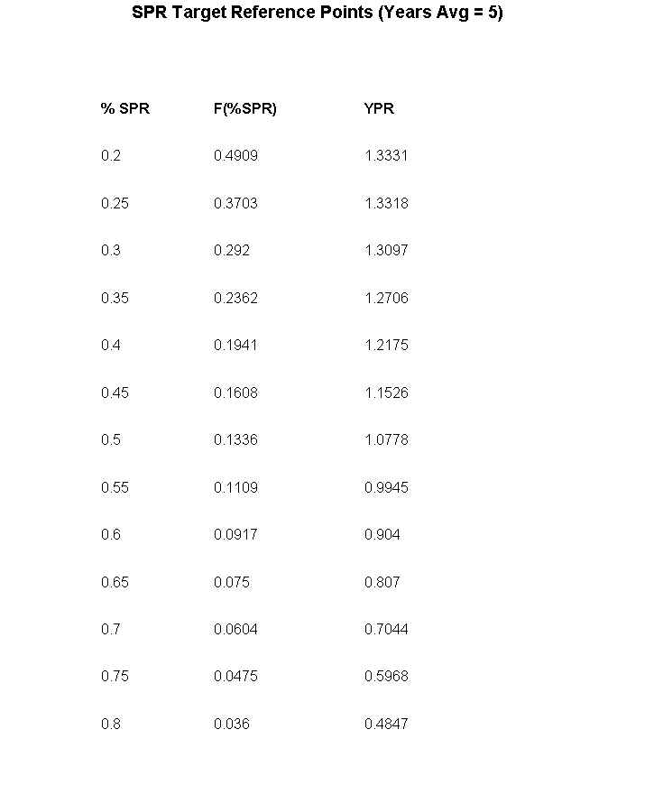
Table 13. ASAP model run3f.1 biomass reference points based on yield per recruit (YPR) and spawner per recruit estimates at F40%.

Table 14. ASAP model run3f.1 projection of spawning stock biomass (SSB), fishing mortality(F), and catch (mt) during 2013-2015 assuming quota taken in 2012 and fishing under F40% .

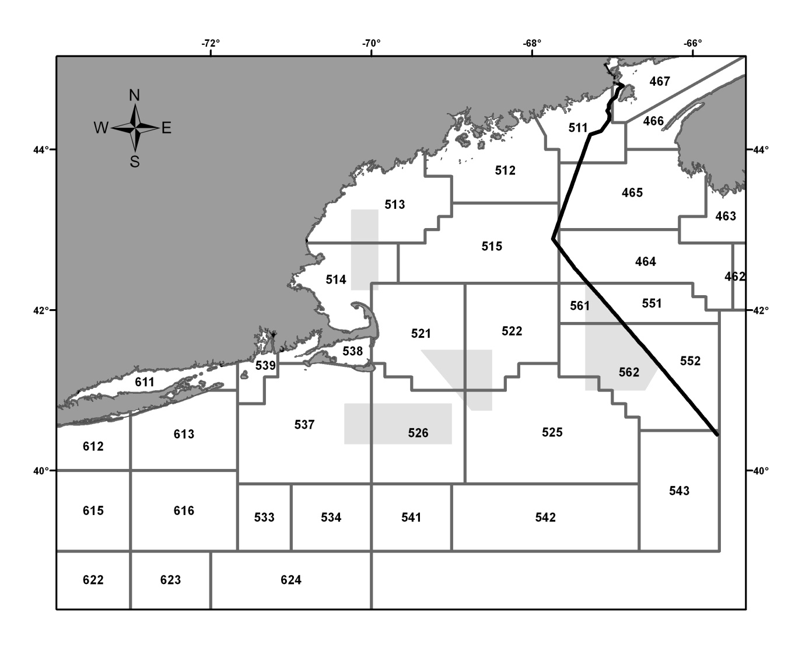

Figure 1. USA statistical areas (SA) for the Gulf of Maine (NAFO Division 5Y; 511-515) and Georges Bank (NAFO Division 5Z;SA 521-525, 551-552,561-562) and south (NAFO Subarea 6).

Figure 2. Canadian Department of Fisheries and Oceans statistical areas (SA) for Georges Bank (NAFO Subdivision 5Ze; SA 5Zj, 5Zm, 5Zn, 5Zo).

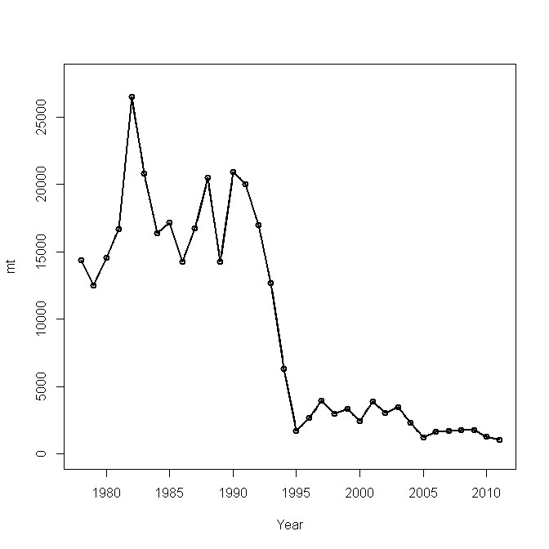

Figure 3. Catch of Eastern Georges Bank cod used in ASAP model, 1978-2011.

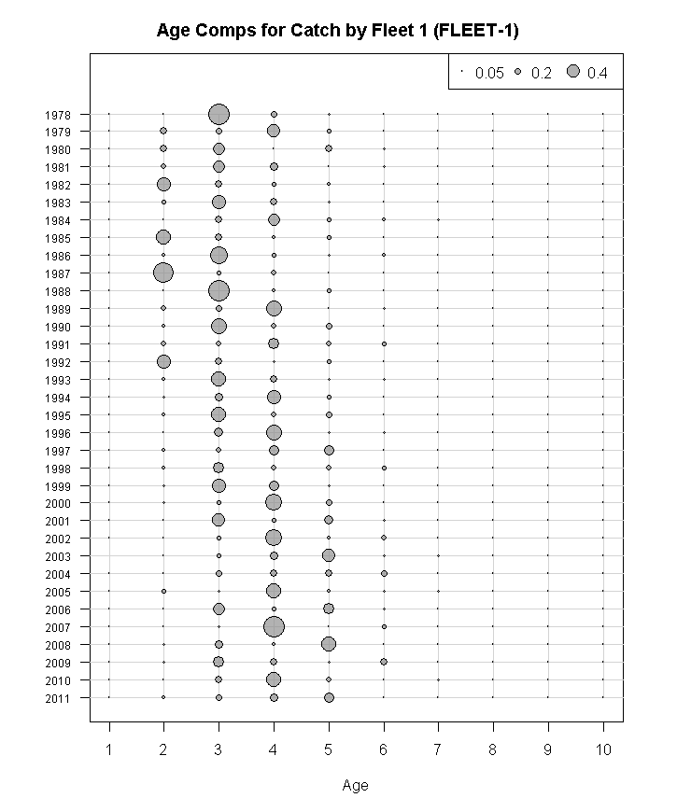

Figure 4. Catch-at-age of Eastern Georges Bank cod, 1978-2011.

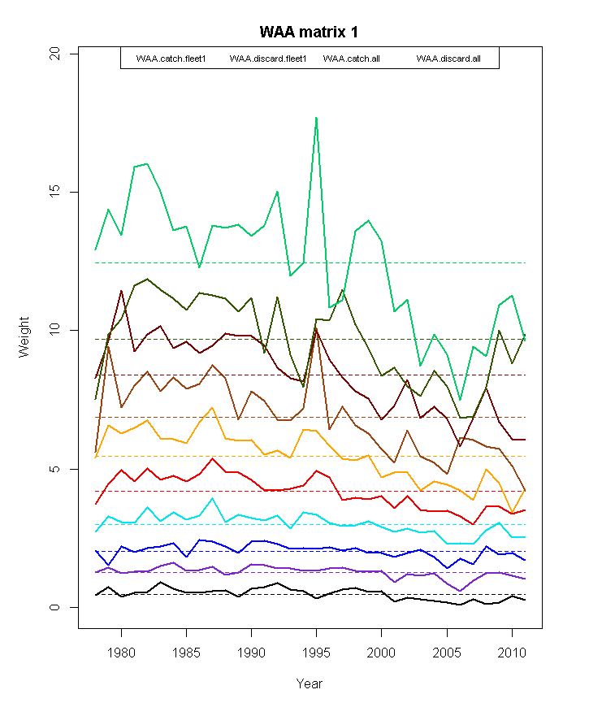

Figure 5. Catch weight-at-age of Eastern Georges Bank cod, 1978-2011.

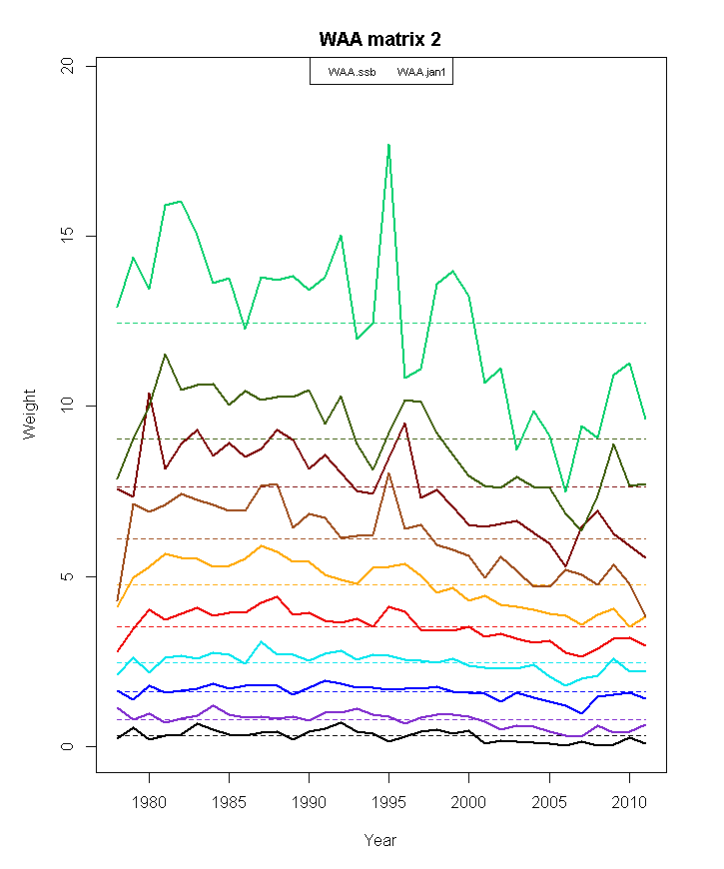

Figure 6. Beginning year catch weight-at-age of Eastern Georges Bank cod , 1978-2011.

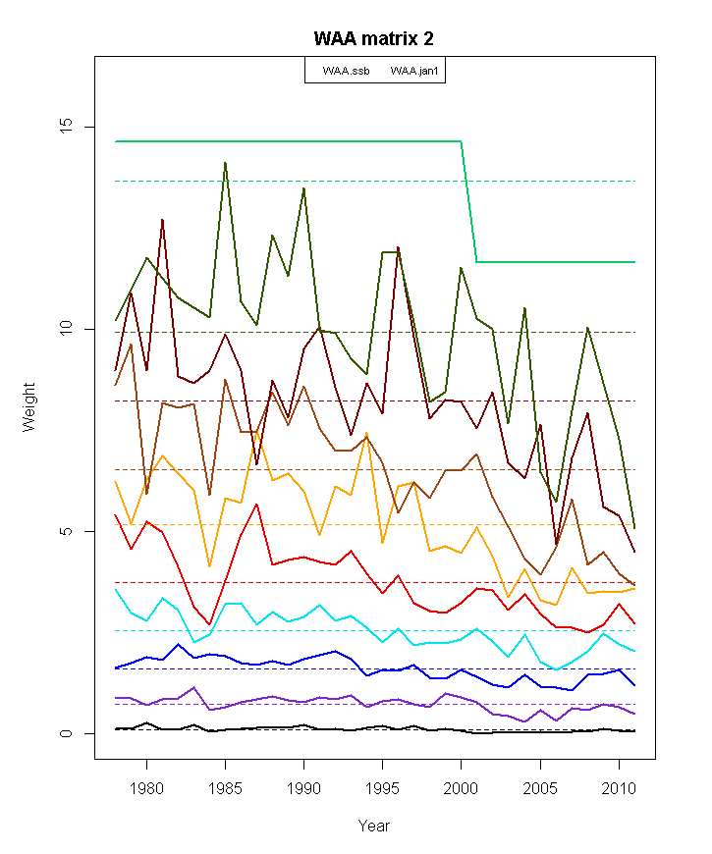

Figure 7. Beginning year weight-at-age of Eastern Georges Bank cod estimated from the DFO and NEFSC spring survey weight-at-age, 1978-2011.

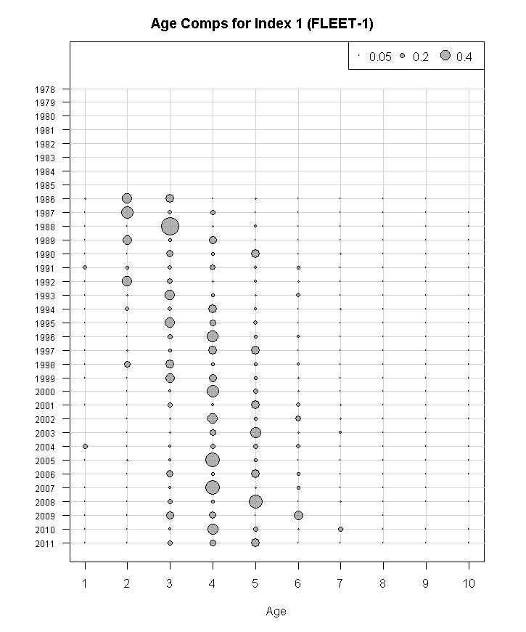

Figure 8. Age composition of stratified mean number catch (numbers) per tow at age of Eastern Georges Bank cod in the DFO research bottom trawl survey (strata 5Z1-5Z4), 1986-2011.

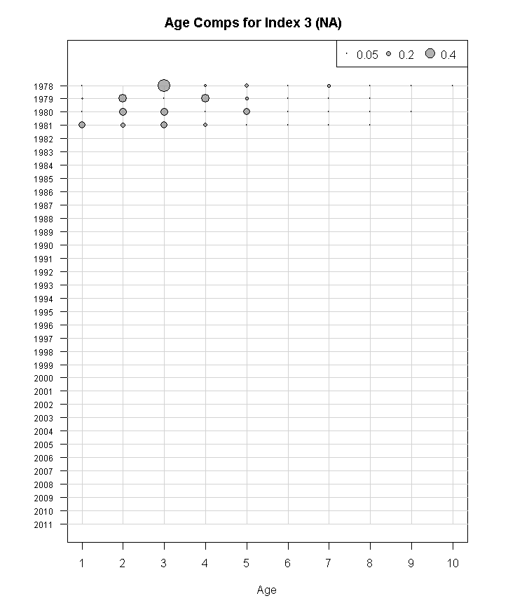

Figure 9a. Age composition of stratified mean number catch (numbers) per tow at age of Eastern Georges Bank cod in the NEFSC spring research bottom trawl survey (Yankee #41 otter trawl), 1978-1981.

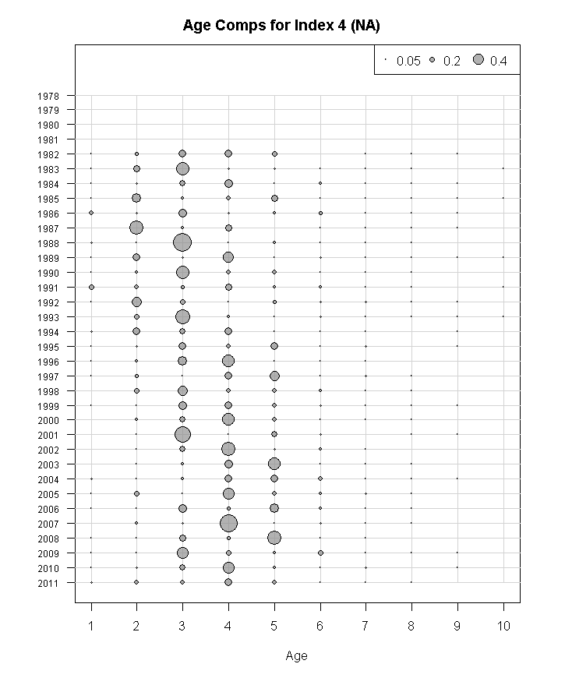

Figure 9b Age composition of stratified mean number catch (numbers) per tow at age of Eastern Georges Bank cod in the NEFSC spring research bottom trawl survey (Yankee #36 otter trawl), 1982-2011.

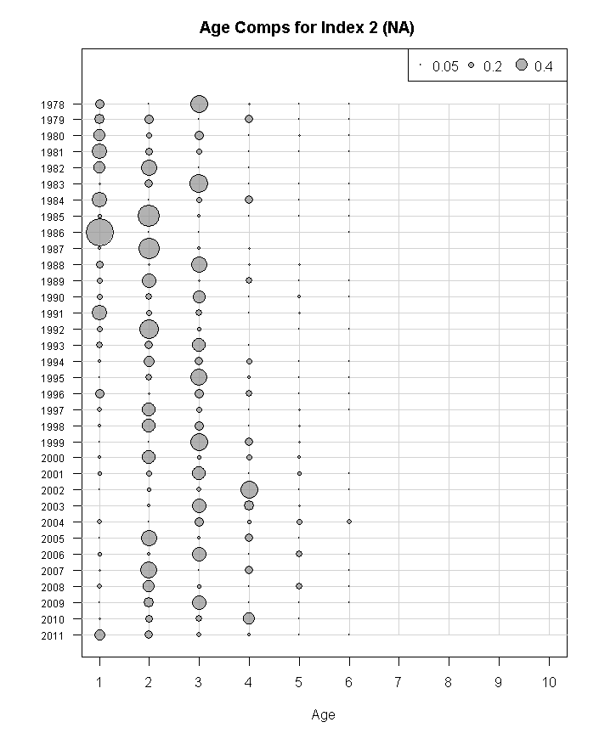
Figure 10. Age composition of stratified mean number catch (numbers) per tow at age of Eastern Georges Bank cod in the NEFSC autumn research bottom trawl survey (Yankee #36 otter trawl), 1978-2011.

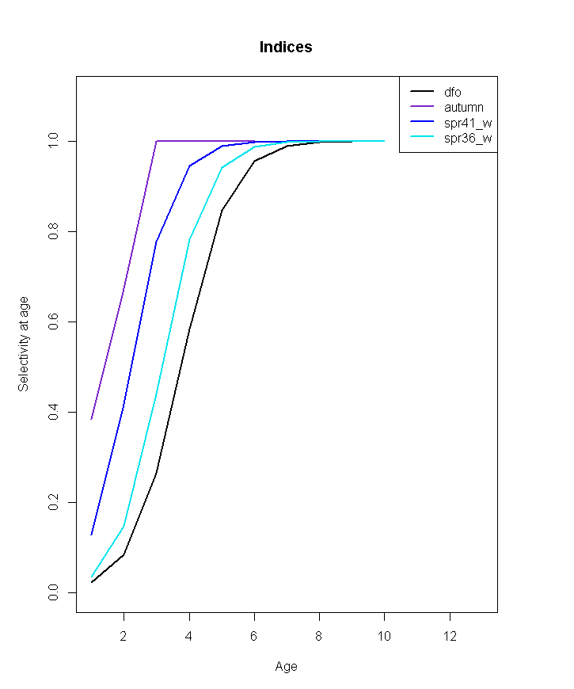

Figure 11. Survey selectivity at age for DFO (logistic), NEFSC autumn (fixed, age 3=1) , and NEFSC spring (logistic) (run1_o3.1).

Figure 12. Fishery selectivity for four blocks from GB cod assessment (NEFSC 2013).

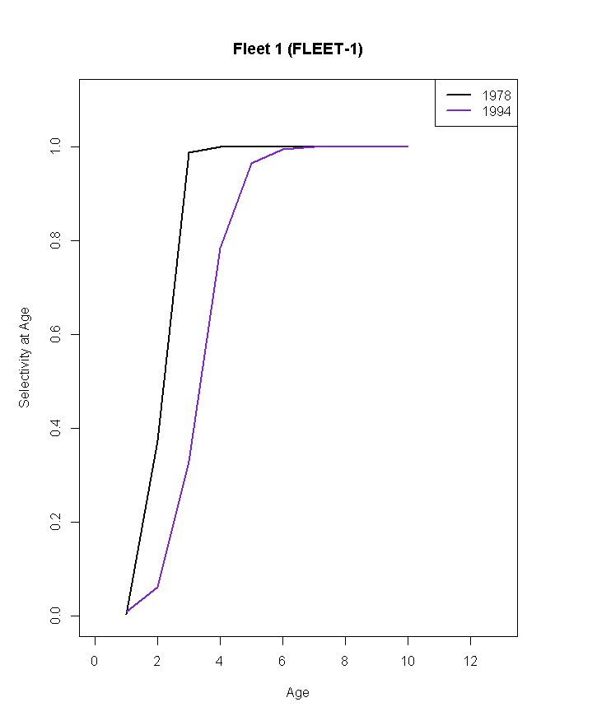

Figure 13. Fishery selectivity for two blocks for EGB cod fishery (run1_o3.1).

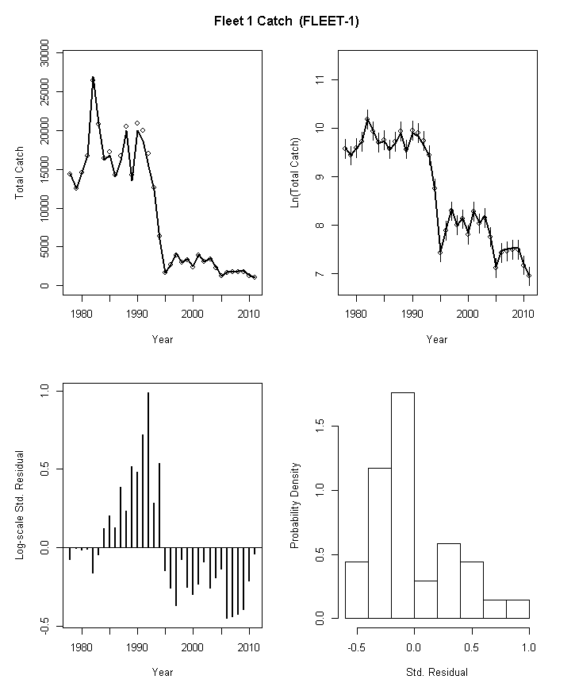

Figure 14. ASAP model run1_o3.1 fit to total catch of Eastern Georges Bank cod, 1978-2011.

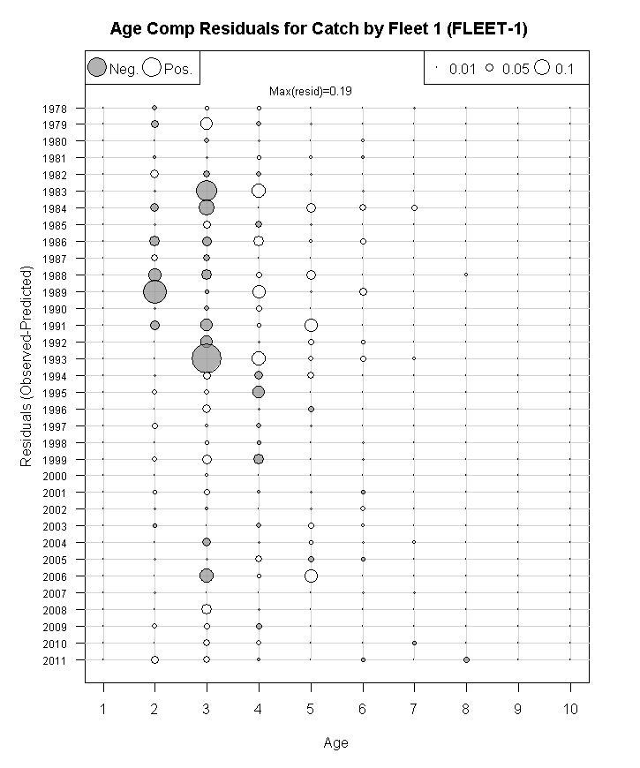

Figure 15. ASAP model run1_o3.1 residuals for the commercial catch age composition of Eastern Georges Bank cod, 1978-2011.

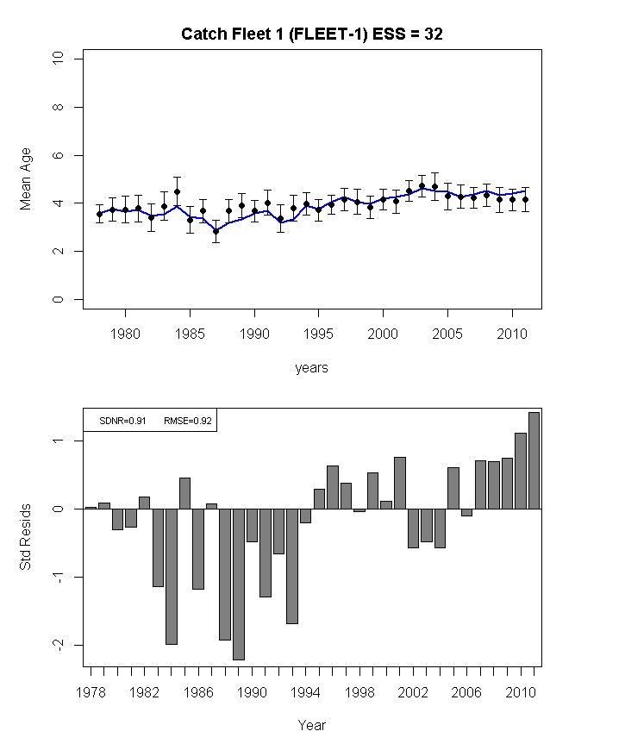

Figure 16. ASAP model run1_o3.1 predicted mean age of Eastern Georges Bank cod in the total catch (blue line) compared to the observed mean age (top plot) and the residuals about the mean (bottom plot), 1978-2011.

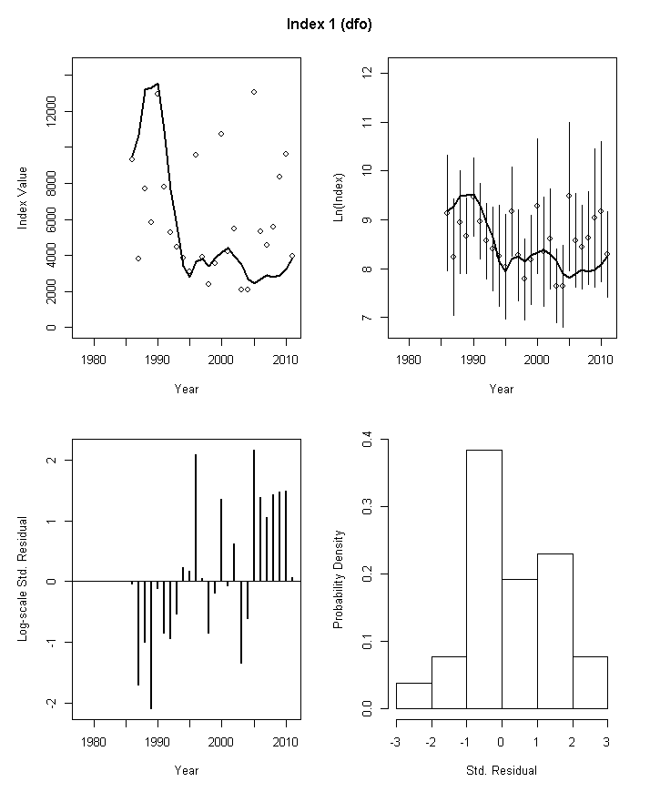

Figure 17. ASAP model run1_o3.1 fit to DFO survey indices of Eastern Georges Bank cod, 1978-2011.

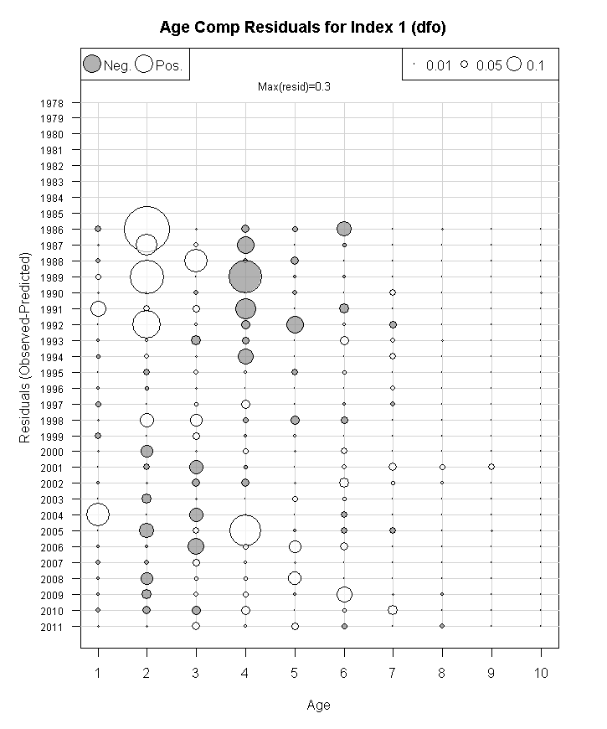

Figure 18. ASAP model run1_o3.1 age composition residuals for DFO survey index of Eastern Georges Bank cod, 1978-2011.

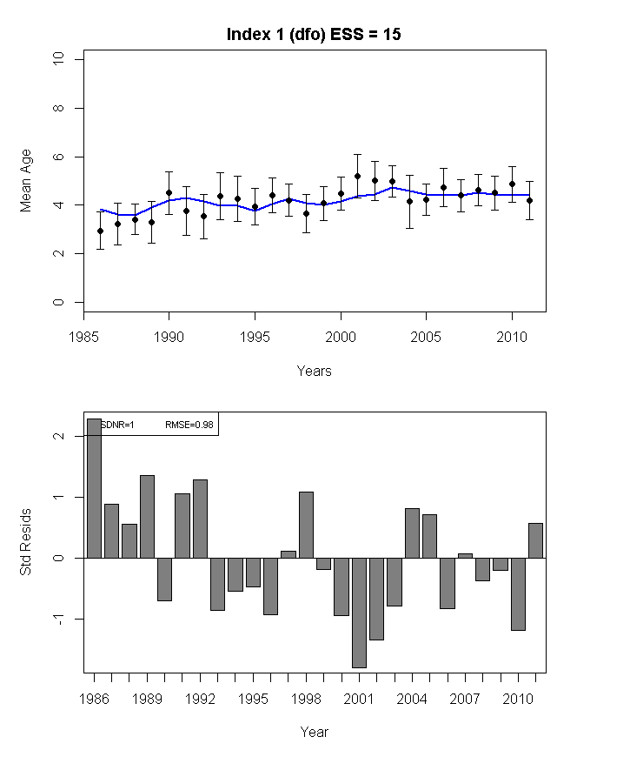

Figure 19. ASAP model run1_o3.1 predicted mean age of Eastern Georges Bank cod in the DFO survey (blue line) compared to the observed mean age (top plot) and the residuals about the mean (bottom plot), 1978-2011.

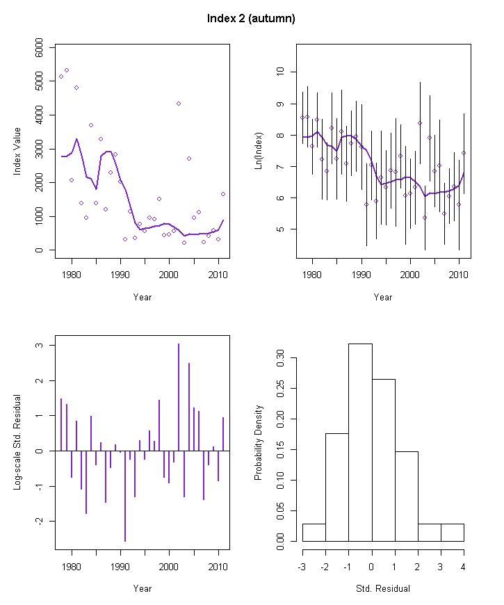

Figure 20. ASAP model run1_o3.1 fit to NEFSC autumn survey indices of Eastern Georges Bank cod, 1978-2011.

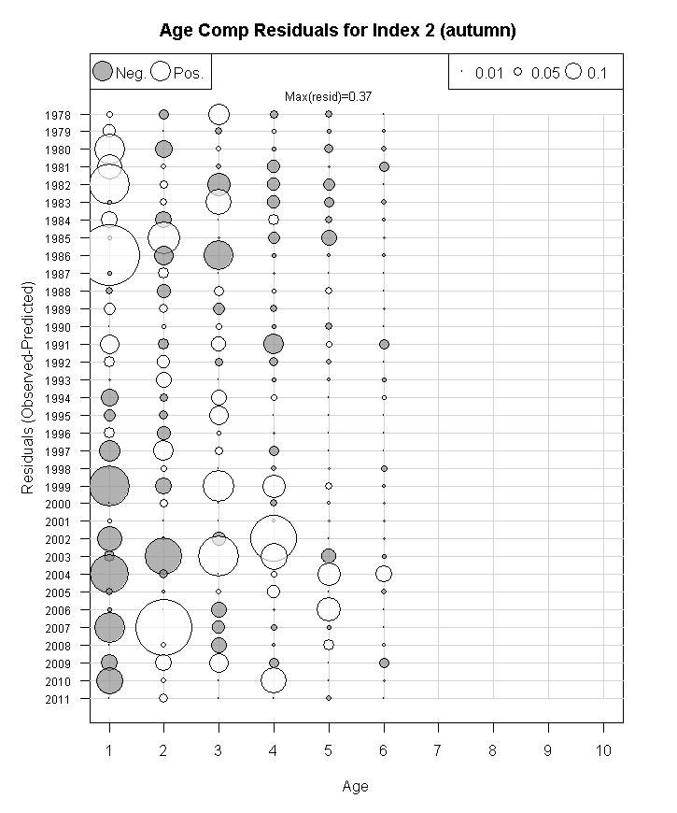

Figure 21. ASAP model run1_o3.1 age composition residuals for NEFSC autumn survey index of Eastern Georges Bank cod, 1978-2011.
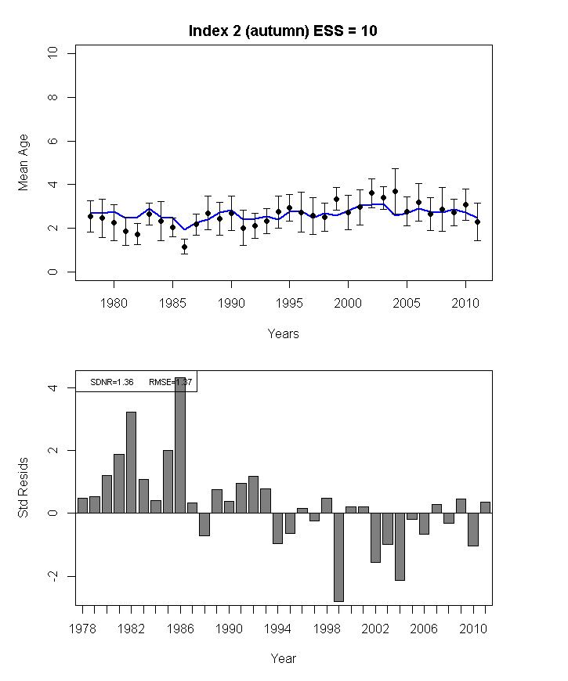

Figure 22. ASAP model run1_o3.1 predicted mean age of Eastern Georges Bank cod in the NEFSC autumn survey (blue line) compared to the observed mean age (top plot) and the residuals about the mean (bottom plot), 1978-2011.

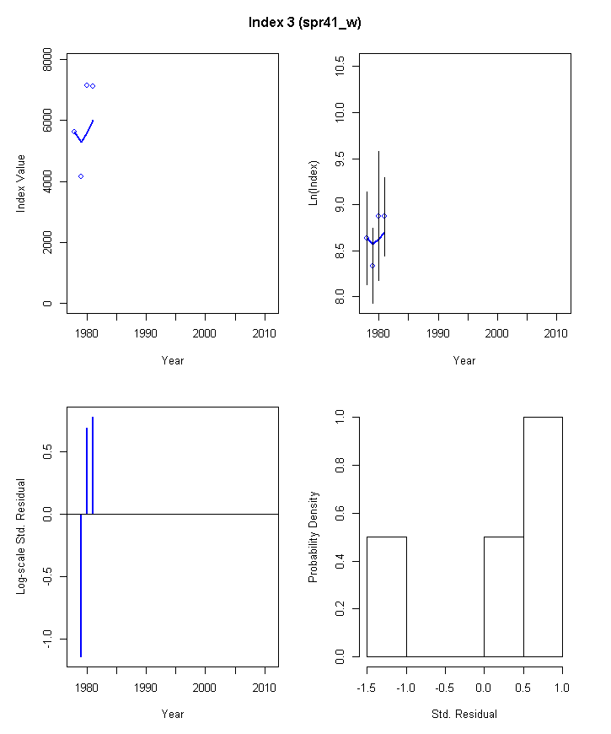

Figure 23. ASAP model run1_o3.1 fit to NEFSC spring Yankee #41 trawl survey indices of Eastern Georges Bank cod, 1978-2011
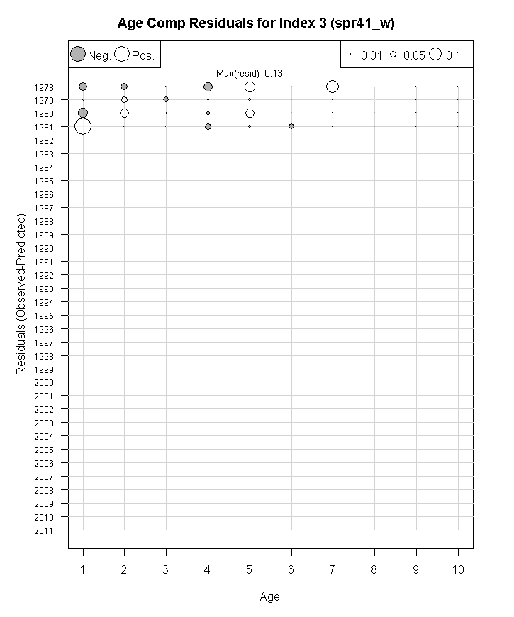

Figure 24. ASAP model run1_o3.1 age composition residuals for NEFSC spring Yankee #41 trawl survey index of Eastern Georges Bank cod, 1978-1981.

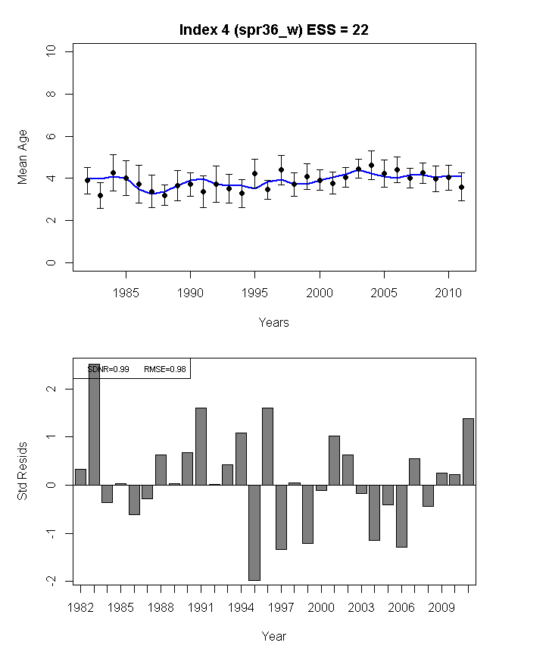

Figure 25. ASAP model run1_o3.1 predicted mean age of Eastern Georges Bank cod in the NEFSC spring Yankee #41 trawl survey (blue line) compared to the observed mean age (top plot) and the residuals about the mean (bottom plot), 1978-1981.

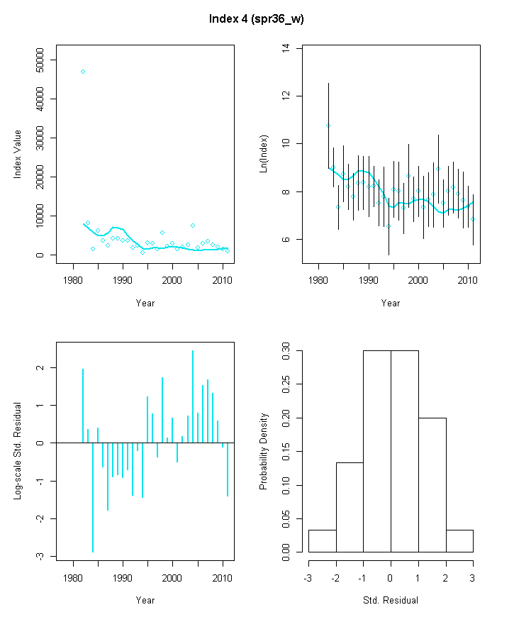

Figure 26. ASAP model run1_o3.1 fit to NEFSC spring Yankee #36 trawl survey indices of Eastern Georges Bank cod, 1982-2011

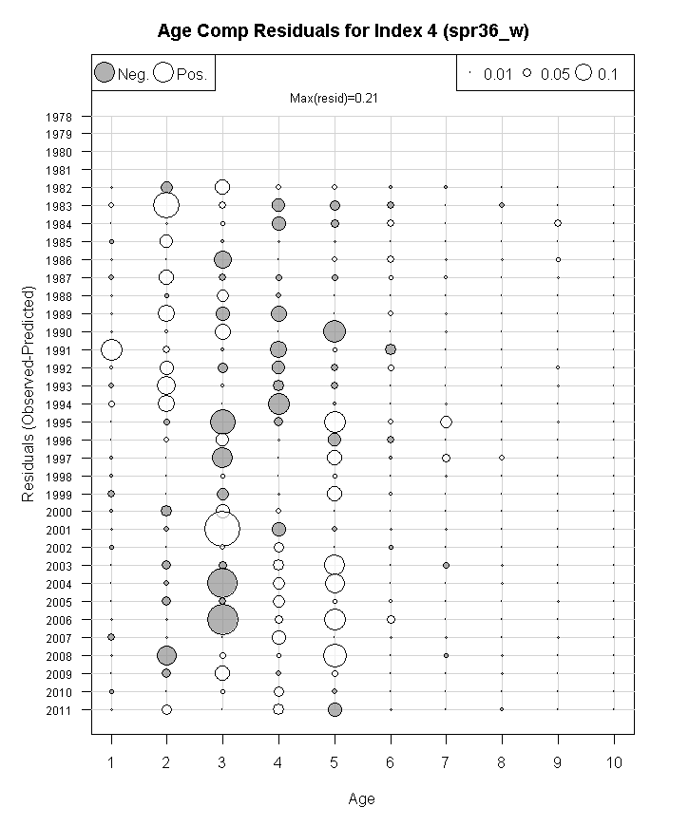

Figure 27. ASAP model run1_o3.1 age composition residuals for NEFSC spring Yankee #36 trawl survey index of Eastern Georges Bank cod, 1982-2011.

Figure 28. ASAP model run1_o3.1 predicted mean age of Eastern Georges Bank cod in the NEFSC spring Yankee #36 trawl survey (blue line) compared to the observed mean age (top plot) and the residuals about the mean (bottom plot), 1982-2011.

Figure 29. ASAP model run1_o3.1 results for fishing mortality (ages 5+), spawning stock biomass, and recruitment (age1, 000s fish), 1978-2011.

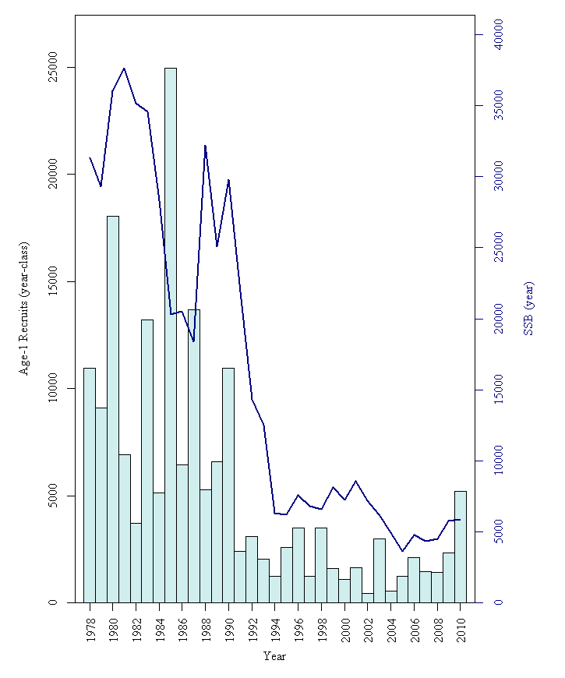
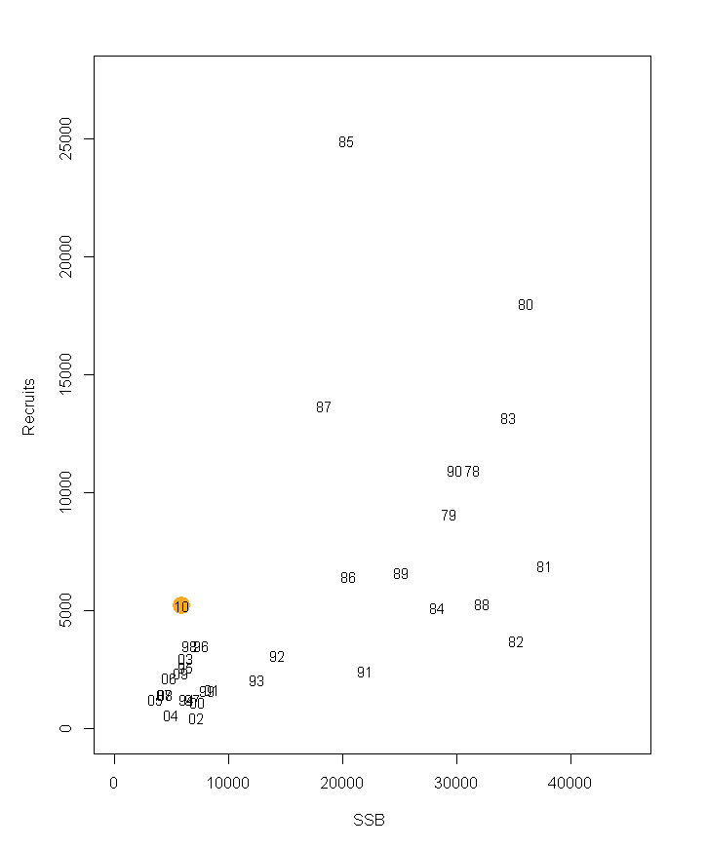

Figure 30. ASAP model run1_o3.1 results for spawning stock biomass (mt) and recruitment (age1, 000s fish), 1978-2011.

Figure 31. ASAP model run1_o3.1 results of retrospective bias of spawning stock biomass (SSB), fishing mortality (F), and age 1 recruitment. Retrospective bias adjustment for SSB=0.723,F=-0.488, age 1 recruitment = -0.265.
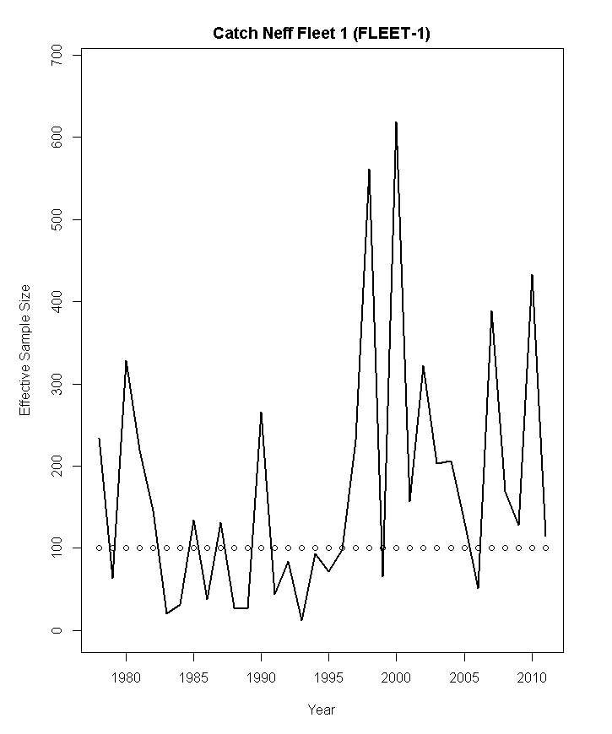

Figure 32. ASAP model run3d.1 observed effective sample size (line) and model predicted effective sample size (circles) for catch.

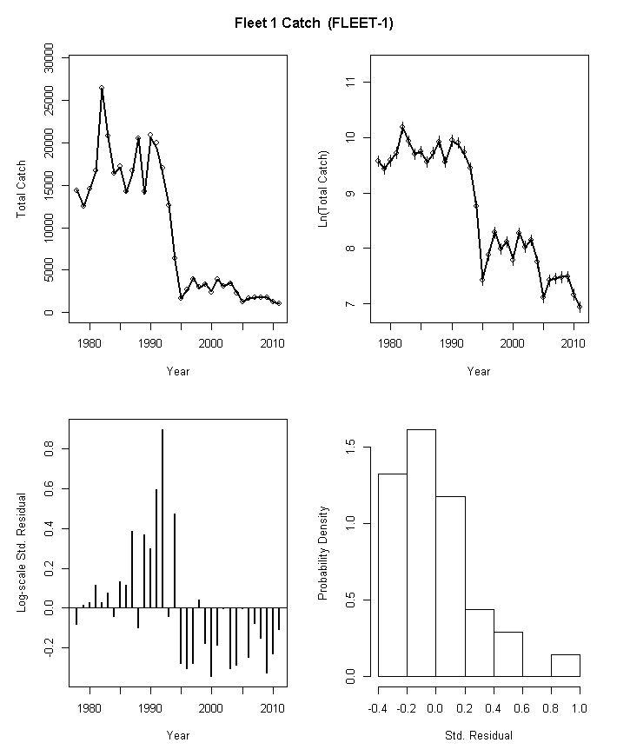

Figure 33. ASAP model run3f.1 fit to total catch of Eastern Georges Bank cod, 1978-2011.

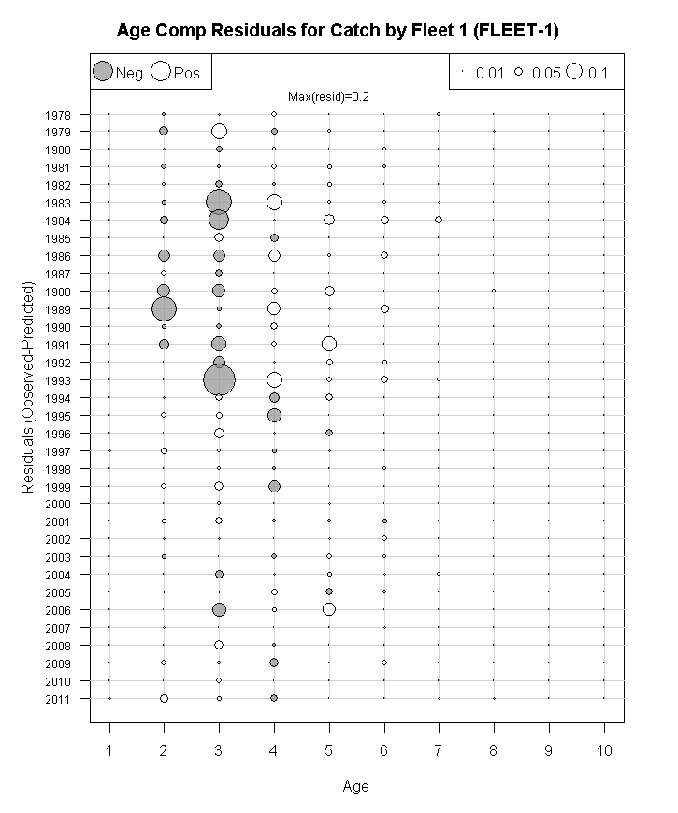

Figure 34. ASAP model run3f.1 residuals for the commercial catch age composition of Eastern Georges Bank cod, 1978-2011.

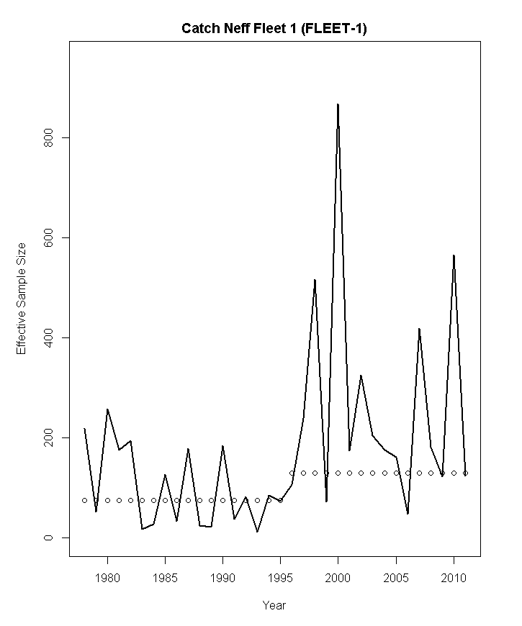

Figure 35. ASAP model run3f.1 observed (line) and predicted (circles) effective sample size of Eastern Georges Bank cod in the total catch, 1978-2011.

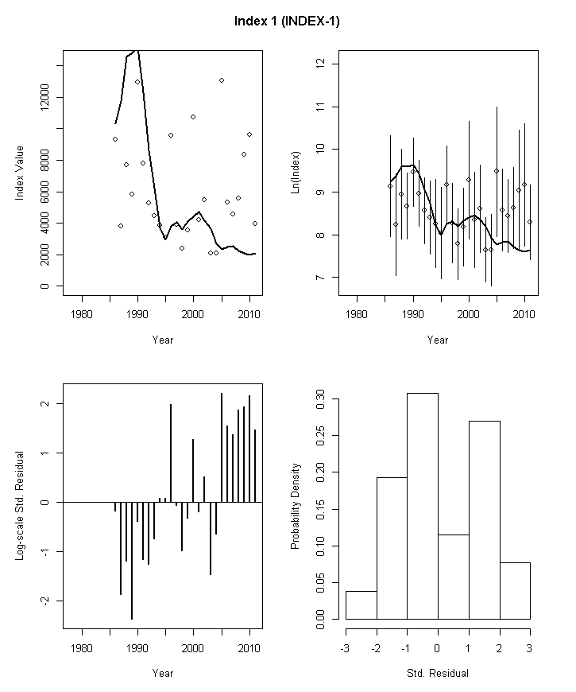

Figure 36. ASAP model run3f.1 fit to DFO survey indices of Eastern Georges Bank cod, 1978-2011.
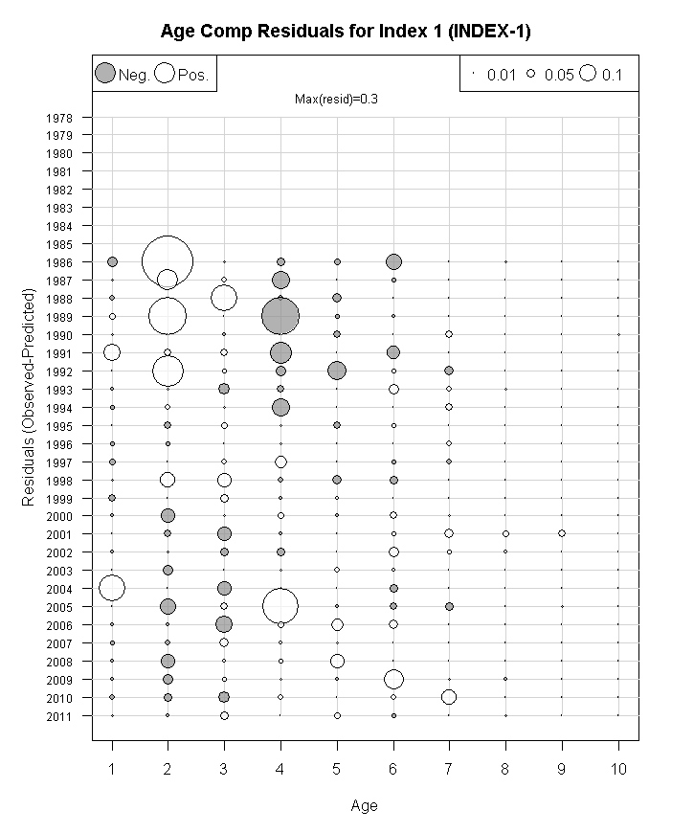

Figure 37. ASAP model run3f.1 age composition residuals for DFO survey index of Eastern Georges Bank cod, 1978-2011.

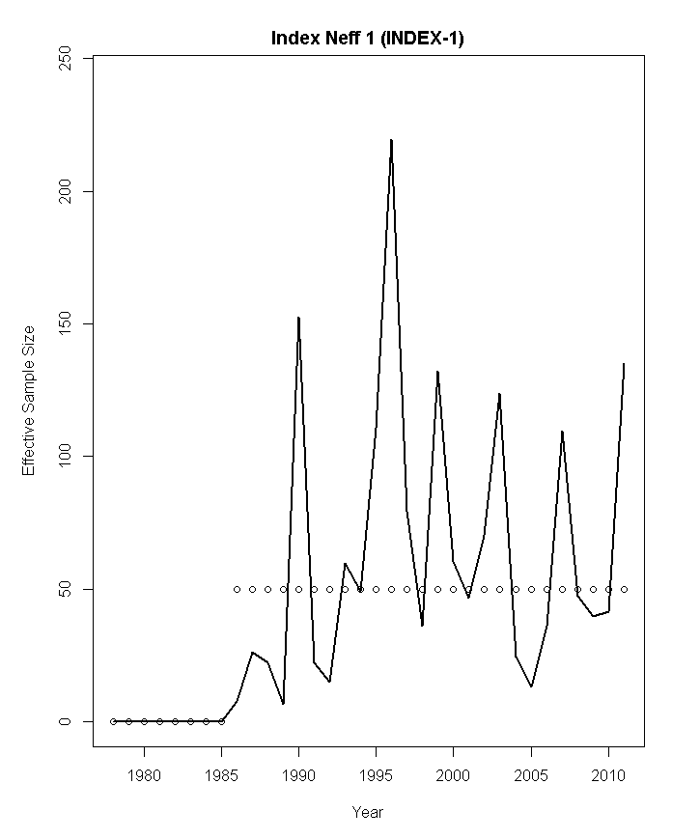

Figure 38. ASAP model run3f.1 observed (line) and predicted (circles) effective sample size of Eastern Georges Bank cod in the DFO survey, 1978-2011.

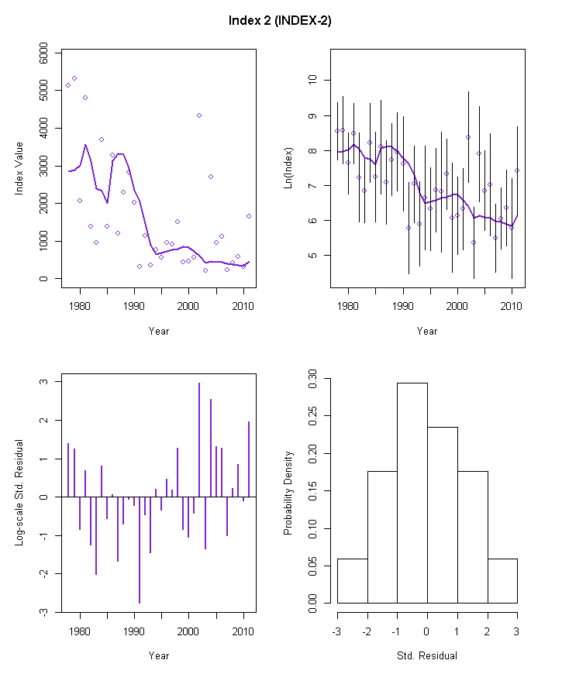

Figure 39. ASAP model run3f.1 fit to NEFSC autumn survey indices of Eastern Georges Bank cod, 1978-2011.

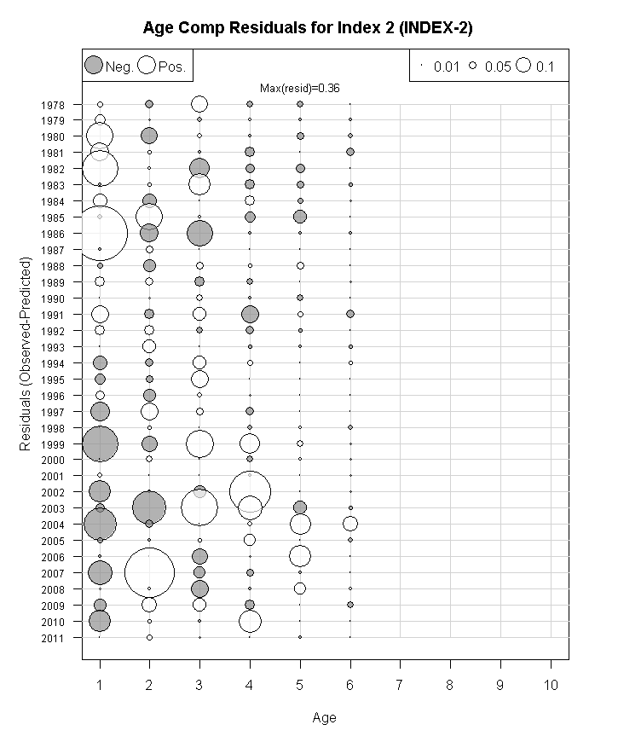

Figure 40. ASAP model run3f.1 age composition residuals for NEFSC autumn survey index of Eastern Georges Bank cod, 1978-2011.

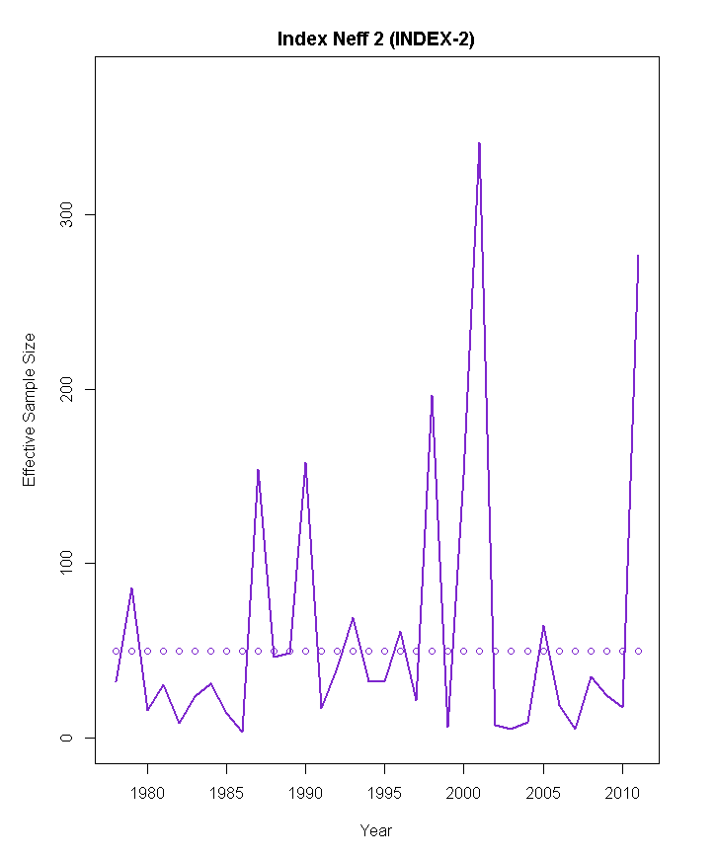

Figure 41. ASAP model run3f.1 observed (line) and predicted (circles) effective sample size of Eastern Georges Bank cod in the NEFSC autumn survey, 1978-2011.

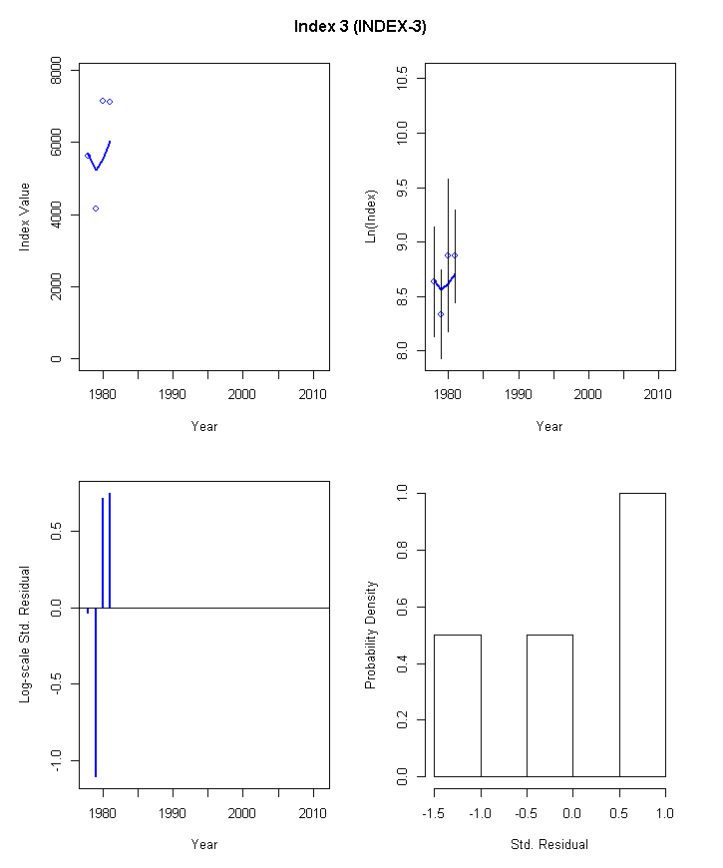

Figure 42. ASAP model run3f.1 fit to NEFSC spring Yankee #41 trawl survey indices of Eastern Georges Bank cod, 1978-2011

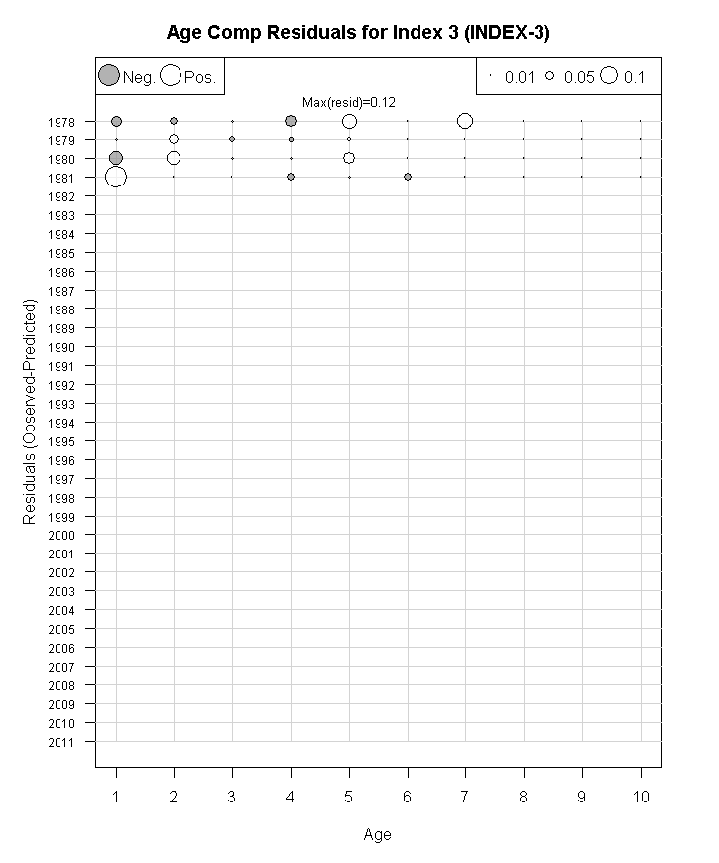

Figure 43. ASAP model run3f.1 age composition residuals for NEFSC spring Yankee #41 trawl survey index of Eastern Georges Bank cod, 1978-1981.

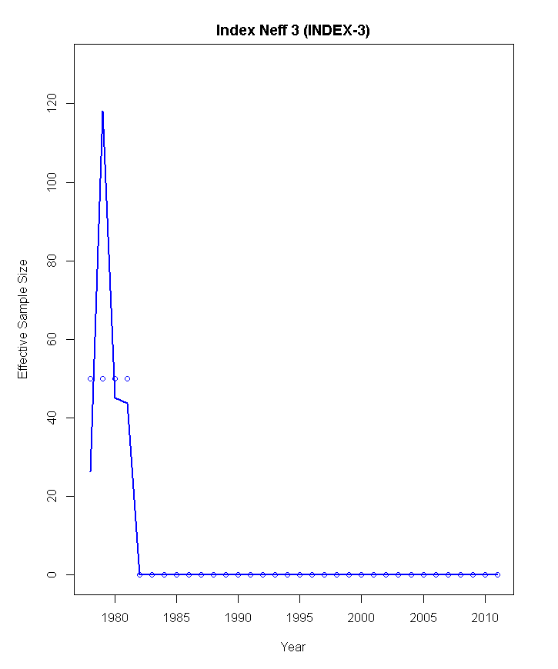

Figure 44. ASAP model run3f.1 observed (line) and predicted (circles) effective sample size of Eastern Georges Bank cod in the NEFSC spring Yankee #41 trawl survey, 1978-2011.

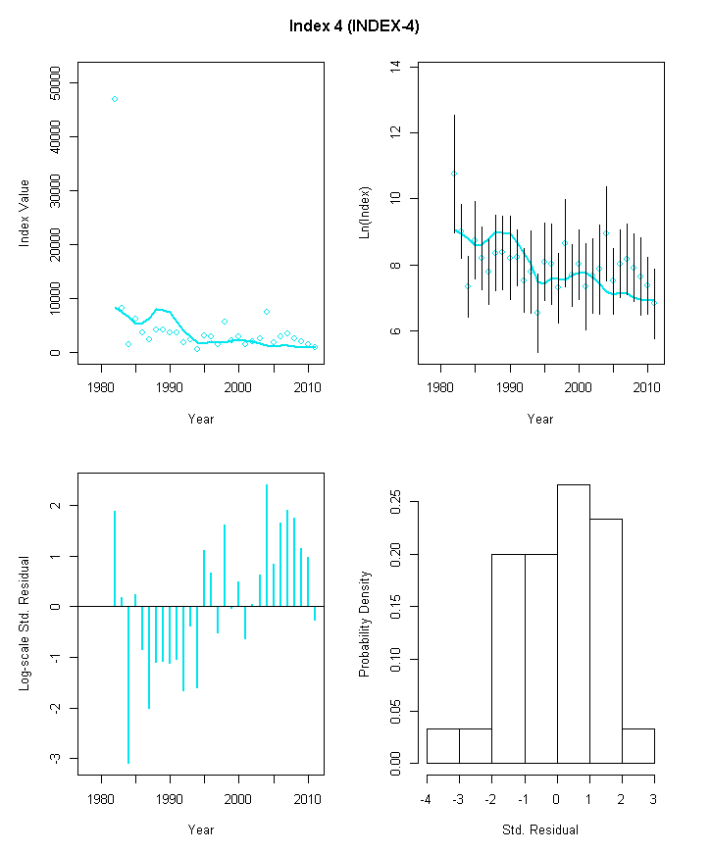

Figure 45. ASAP model run3f.1 fit to NEFSC spring Yankee #36 trawl survey indices of Eastern Georges Bank cod, 1982-2011

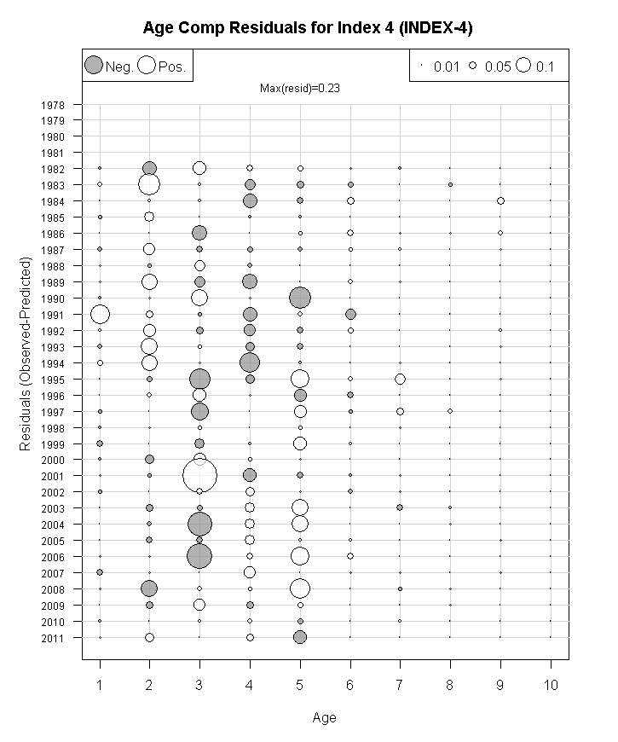

Figure 46. ASAP model run3f.1 age composition residuals for NEFSC spring Yankee #36 trawl survey index of Eastern Georges Bank cod, 1982-2011.
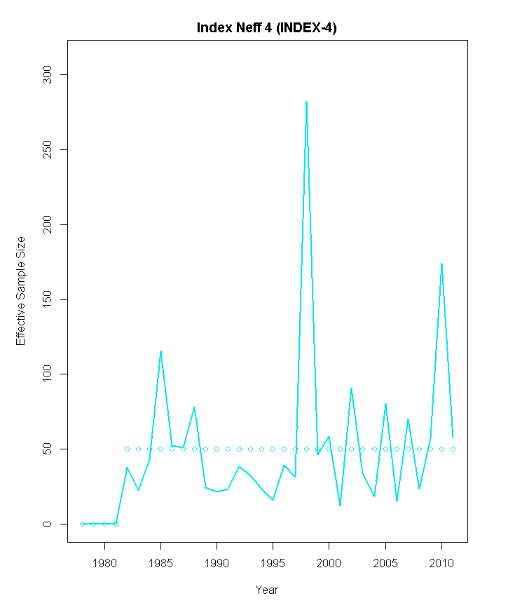

Figure 47. ASAP model run3f.1 observed (line) and predicted (circles) effective sample size of Eastern Georges Bank cod in the NEFSC spring Yankee #36 trawl survey, 1982-2011.

Figure 48. ASAP model run3f.1 results for fishing mortality (ages 5+), spawning stock biomass, and recruitment (age1, 000s fish), 1978-2011.

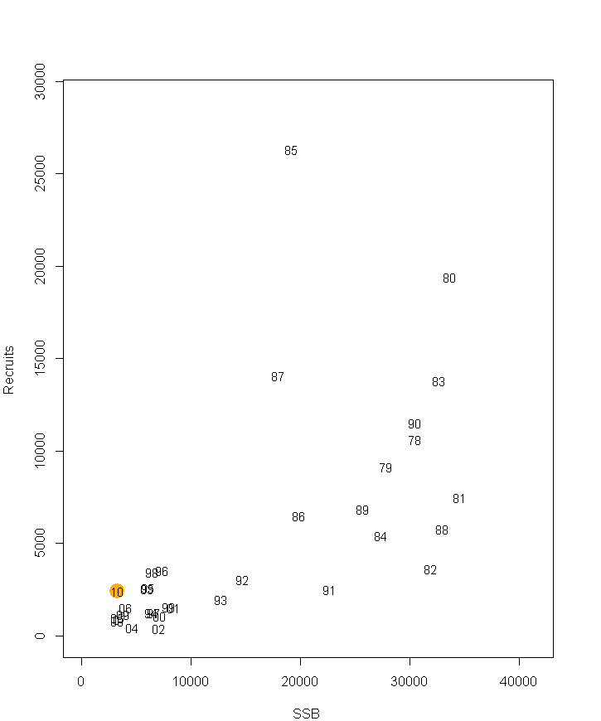
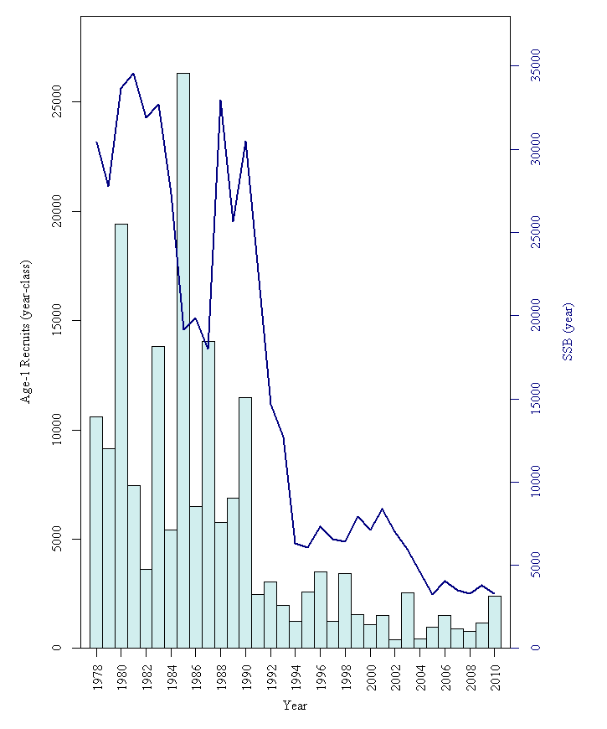

Figure 49. ASAP model run3f.1 results for spawning stock biomass (mt) and recruitment (age1, 000s fish), 1978-2011.

Figure 50. ASAP model run3f.1 results of retrospective bias of fishing mortality (F), spawning stock biomass (SSB), and age1 recruitment. Retrospective bias adjustment for
F= -0.475, SSB=0.025, and age 1 recruitment = -0.528.

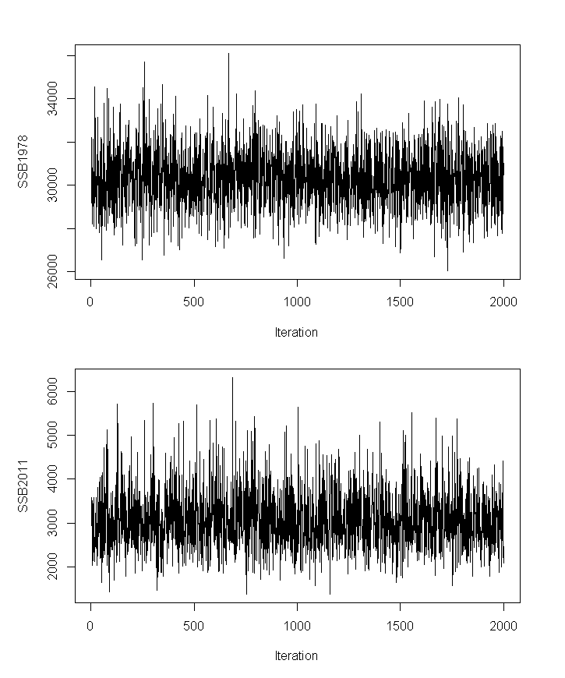

Figure 51. ASAP model run3f.1 results of trace of MCMC chains for Eastern Georges Bank cod spawning stock biomass for 1978 and 201. Each chain had an initial length of 5.0 million and was thinned at a rate of one out of every 2,500th resulting in a final chain length of 2000.

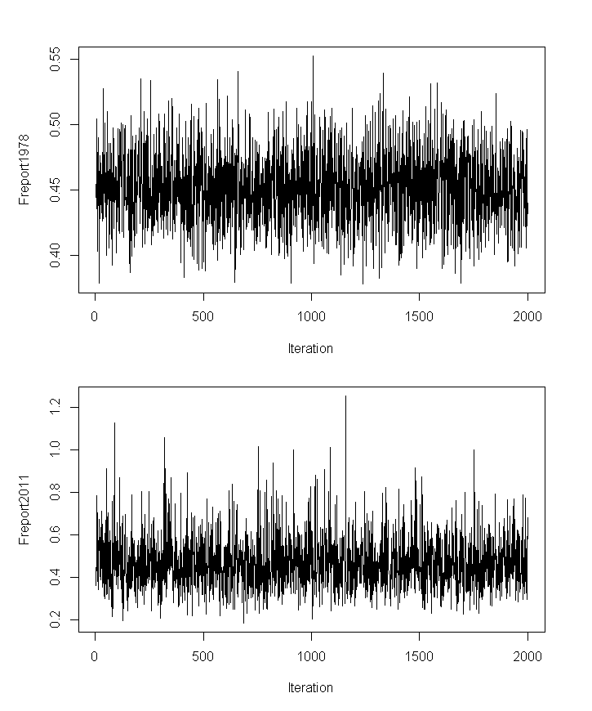

Figure 52. ASAP model run3f.1 results of trace of MCMC chains for Eastern Georges Bank cod fishing mortality for 1978 and 201. Each chain had an initial length of 5.0 million and was thinned at a rate of one out of every 2,500th resulting in a final chain length of 2000.

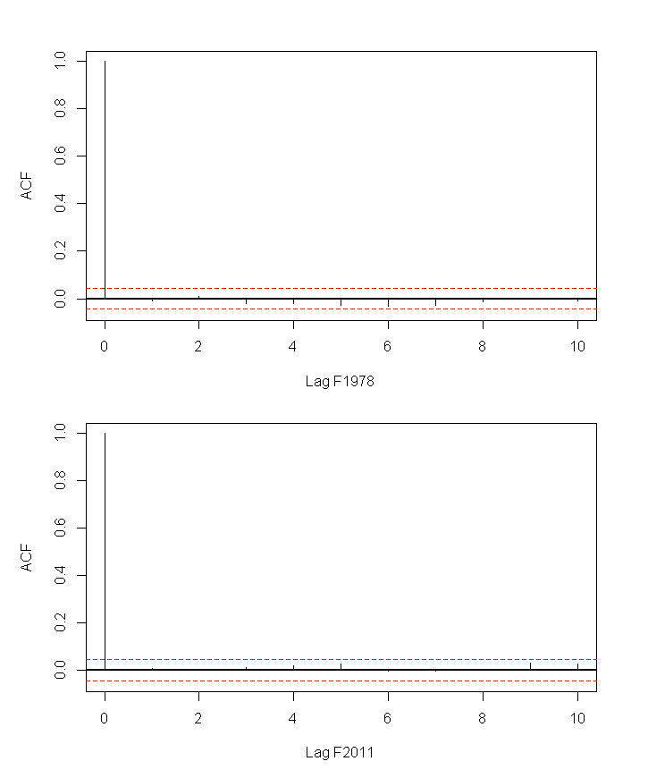
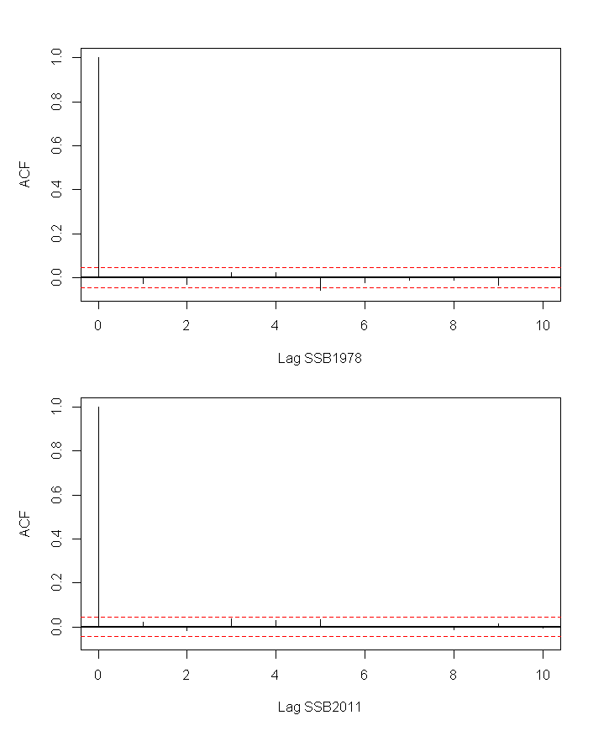

Figure 53. ASAP model run3f.1 autocorrection within the 1978 and 2011 MCMC chains for spawning stock biomass (SSB, left panel) and fishing mortality (F, right panel) for Eastern Georges Bank cod.

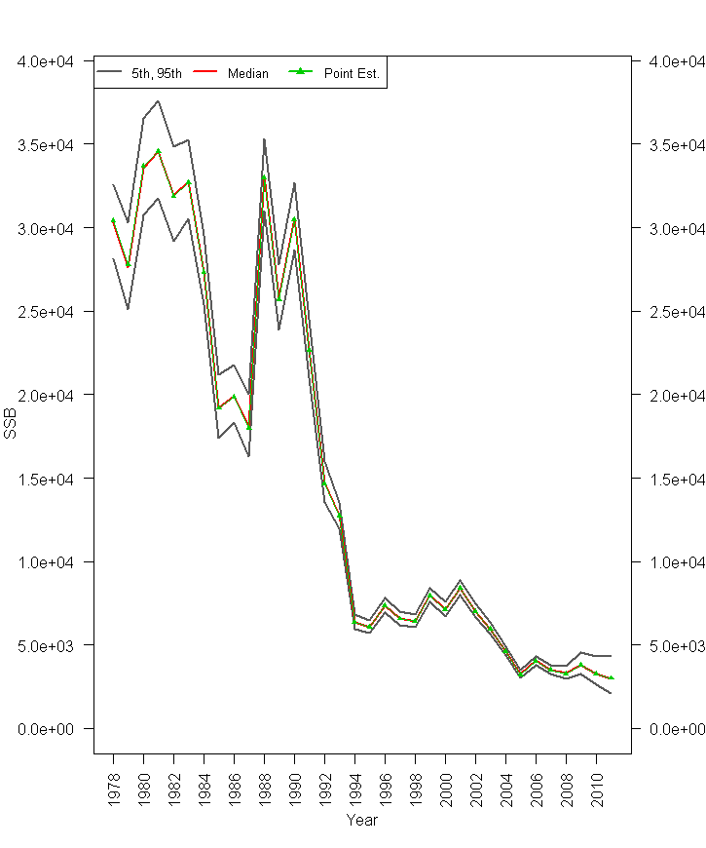

Figure 54. ASAP model run3f.1 90% probability interval for Eastern Georges Bank cod spawning stock biomass (SSB). The median value is in red, while the 5th and 95th percentiles are in dark grey. The point estimate from the model (joint posterior modes) is shown in the thin green line with filled triangles.
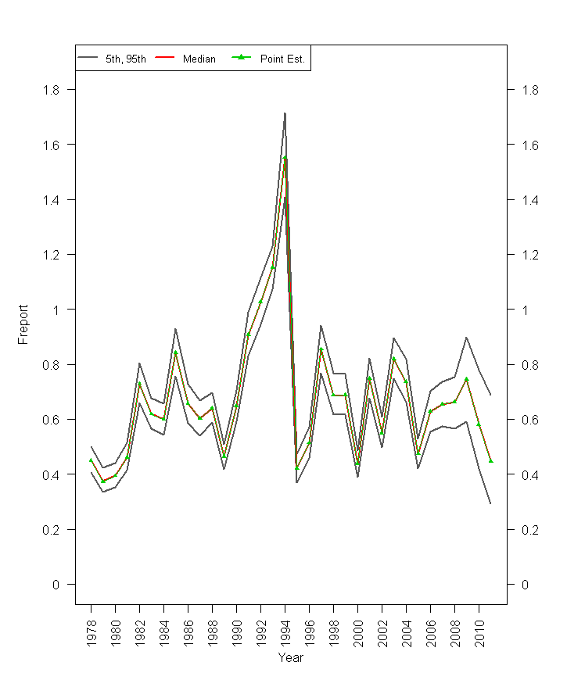

Figure 55. ASAP model run3f.1 90% probability interval for Eastern Georges Bank cod fishing mortality (F). The median value is in red, while the 5th and 95th percentiles are in dark grey. The point estimate from the model (joint posterior modes) is shown in the thin green line with filled triangles.

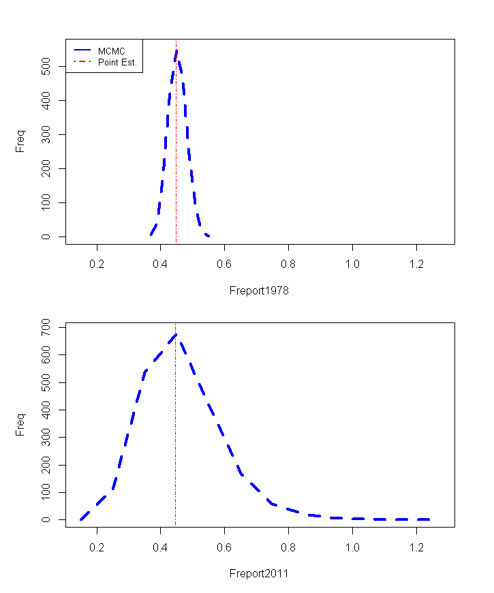
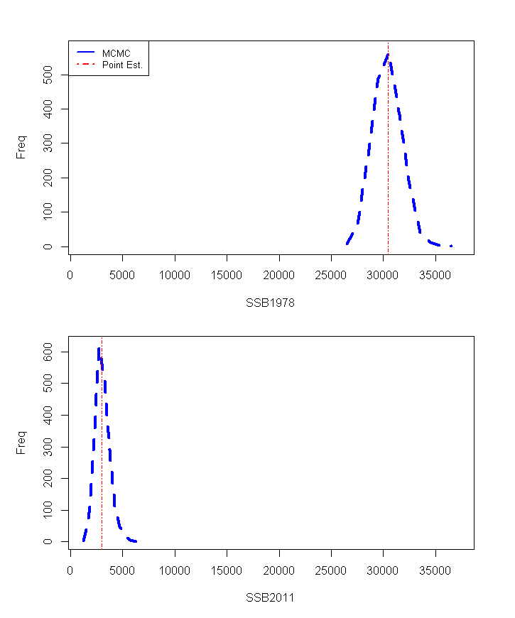

Figure 56. ASAP model run3f.1 MCMC distribution of Eastern Georges Bank cod spawning stock biomass (SSB, left panel) and fishing mortality (F, right panel) in 1978 and 2011. The model point estimate is indicated by the dashed red line.

Figure 57. Upper and lower bound estimate of total biomass for each surveyfro the ‘envelope anlaysis’ (see WP 2013/9) with ASAP Jan1 biomass estimated from model run3f.1.
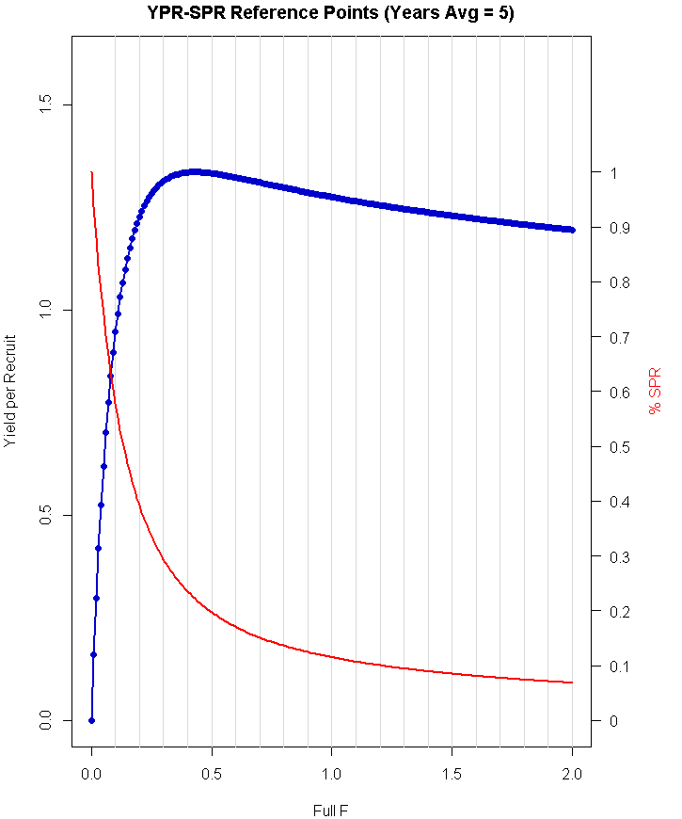

Figure 58. ASAP model run3f.1 Yield per recruit (YPR) analysis and percent spawning potential ratio (%SPR).

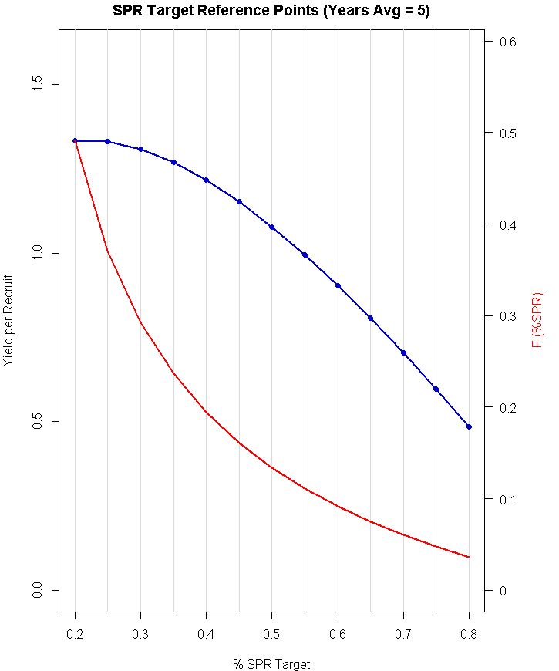

Figure 59. ASAP model run3f.1 Yield per recruit (YPR) and fishing mortality (F) at percent t spawning potential ratio (%SPR) targets.

